DATA ANALYSIS OF NETFLIX'S CONTENT AND TRENDS

REPORT IS SUBMITTED IN PARTIAL FULFILLMENT OF THE REQUIREMENT OF THE DIPLOMA
IN
COMPUTER ENGINEERING
UNDER THE SUPERVISION OF
Ms. JAISHREE
BY
RAJ GURU (Roll No. 2236051022)
MAY - JUNE 2025


ADITYA INSTITUTE OF TECHNOLOGY
(Unit of Dr. R.N. Gupta Technical Educational Society)
AFFILIATED TO BOARD OF TECHNICAL EDUCATION, DELHI - 110088
DECLARATION
This is to certify that this project report entitled “Data Analysis of Netflix's Content and Trends” which is submitted by me in partial fulfillment of the requirement for the award of Diploma in Computer Engineering to Aditya Institute of Technology, Delhi comprises only my original work and due acknowledgement has been made in text to all material used.
Date: 17/03/2025
Student’s Name: RAJ GURU
Roll No. 2236051022

SUBMITTED TO:
Ms. JAISHREE
Lecturer (Computer Engineering)

CERTIFICATE
This is to certify that this project report entitled “Data Analysis of Netflix's Content and Trends” which is submitted by Raj Guru (2236051022) in partial fulfillment of the requirement for the award of Diploma in Computer Engineering to Aditya Institute of Technology, Delhi is a record of student’s own work carried out by him under my supervision. The matter embodied in this report is original and has not been submitted for the award of any other degree.
Date: 17/03/2025
(Signature)
Ms. JAISHREE
ACKNOWLEDGEMENT
I express my heartiest gratitude and respectful regards to Ms. Jaishree, my project guide, for her valuable guidance, constructive criticism and consistent enthusiastic interest during the course of investigation and writing of manuscript that led this work to its successful completion. I regard my sincere thanks to the technical staff at the organization that helped me during the project and made this project successful.
I would also like to express my profound sense of gratitude to our internal guide Ms. Jaishree, Lecturer of the Department of Computer Engineering, Aditya Institute of Technology, for her support and encouragement while doing the project. Last but not the least, I am thankful to my parents and friends for their constant support and motivation throughout this journey.
I am highly indebted to the Department of Computer Engineering, Aditya Institute of Technology for their continuous support regarding our project report.

INDEX
CHAPTER 1 INTRODUCTION
1.1 Introduction
1.2 Project Objective
1.3 Project Design Issues
1.4 Power Consumption
1.5 Reliability
CHAPTER 2 OVERVIEW OF PROJECT
2.1 Dataset Description
2.2 Tools & Technologies Used
2.3 Data Overview
2.4 Data Cleaning & Transformation
2.5 Project Layout & Structure
CHAPTER 3 WORKING OF PROJECT
3.1 Step-by-Step Working
3.2 Analysis Modules & Logic
3.3 Limitations
3.4 Advantages
3.5 Disadvantages
CHAPTER 4 APPLICATIONS & SCOPE
4.1 Real-World Applications
4.2 Scope for Future Work
CHAPTER 5 HARDWARE & SOFTWARE USED
5.1 Software Stack
5.2 Tools & Libraries Used
CHAPTER 6 RESULTS AND DISCUSSION
6.1 Data Analysis Results (Charts, Tables, Findings)
6.2 Conclusion
CHAPTER 7 REFERENCES

CHAPTER 1 - INTRODUCTION

1.1 Introduction
This project titled “Data Analysis of Netflix’s Content and Trends” focuses on analyzing the vast content library of Netflix using data science techniques. The Netflix platform has become a global hub for entertainment, offering a wide range of TV shows, movies, documentaries, and stand-up comedy shows. This project aims to gain insights into various aspects such as genre distribution, country-wise content, content ratings, release year trends, and more using Python libraries and data visualization tools.

1.2 Project Objective
The main goal of this project is to understand Netflix’s content using data. We want to find answers to questions like:
- How many movies and TV shows are there?
- Which genres (like drama or comedy) are most popular?
- Which countries make the most content?
- What are the different types of content ratings?
- How has Netflix’s content grown over the years?

1.3 Project Design Issues
While working on this project, we faced a few problems like:
- Understanding the distribution of movies and TV shows.
- Identifying the most common genres and popular content.
- Analyzing country-wise contributions to Netflix’s content.
- Understanding content rating distribution and duration trends.
- Creating clear and easy-to-understand charts was important.

1.4 Power Consumption
This project is software-based and does not involve hardware components. Therefore, power consumption is negligible and only depends on the computing system used.

1.5 Reliability
The project uses a publicly available Netflix dataset which is consistent and reliable for performing content-based analysis. The findings and visualizations generated are repeatable and reproducible using the same dataset and methodology.

CHAPTER 2 - OVERVIEW OF PROJECT

2.1 Dataset Description
This project uses a dataset called ‘netflix_titles.csv’. It contains details about movies and TV shows available on Netflix. Some of the main details in the dataset are:
- Title: Name of the show or movie
- Type: Movie or TV Show
- Director and Cast: People who made and acted in it
- Country: Where it was made
- Release Year: Year it was released
- Rating: Age group recommendation like PG, R, etc.
- Duration: Length of movie or number of seasons
- Genre: Type of content like Drama, Comedy, etc.

2.2 Tools and Technologies Used
We used the following tools and software to complete the project:
- Python: For data analysis and cleaning
- Jupyter Notebook: To write and run Python code
- Pandas: To work with data in table format
- NumPy: For basic math operations
- Plotly Express: For creating charts and graphs

2.3 Data Overview
The dataset was loaded and the first step was to check how the data looks. We used simple commands to see the first few rows of the table and understand the structure of the data. This helped us plan what to analyze.

2.4 Data Cleaning and Transformation
Before analyzing, we cleaned the data:
- Removed rows with missing values.
- Dropped columns we did not need.
- Changed the date format to proper year format.
- Renamed columns for better understanding.
- Removed duplicate rows.
- Selected only the first genre if multiple genres were listed.

2.5 Project Layout and Structure
The project was divided into the following steps:
1. Importing libraries
2. Loading the dataset
3. Cleaning the data
4. Analyzing the data using charts
5. Finding insights and writing the conclusion
All these steps were written and run inside a Jupyter Notebook. Each section has code and its output clearly shown in the notebook.

CHAPTER 3 - WORKING OF PROJECT

3.1 Step-by-Step Working
Here is a simple explanation of how the project works step by step:
1. Import Python libraries like Pandas, NumPy, and Plotly.
2. Load the Netflix dataset using Pandas.
3. Clean the data by removing empty rows and fixing date formats.
4. Rename some columns and remove extra columns.
5. Analyze the data using graphs and charts.
Each step was written in code in a Jupyter Notebook and the results were shown in the form of charts and tables.

3.2 Analysis Modules and Logic
We performed different types of analysis on the dataset. Here are some of them:
- Count of Movies vs TV Shows using a pie chart.
- Top 5 directors with most titles using a bar chart.
- Most common genres like Drama and Comedy.
- Countries that have the most content like USA and India.
- Rating distribution like TV-MA, PG, etc.
- Average duration of movies by genre.
- Number of titles released each year.
- Top genres in Indian content.
- Most common release years in USA content.

3.3 Limitations
Some limitations of this project are:
- The dataset may not be updated with latest titles.
- Some data may be missing or incomplete.
- The analysis is based only on available data, not user preferences or views.

3.4 Advantages
Some advantages of this project are:
- Helps understand Netflix content better.
- Easy to use tools and libraries.
- Visual charts make the data easy to understand.
- Can be extended with more datasets in future.

3.5 Disadvantages
Some disadvantages are:
- Cannot suggest content to users.
- Cannot measure popularity or watch time.
- Limited only to content data, not user behavior.

CHAPTER 4 - APPLICATIONS & SCOPE OF THE PROJECT

4.1 Real-World Applications
This project can be used in many real-world situations. Some examples are:
- Media Companies can understand what type of content people like.
- Streaming Platforms can use such analysis to improve their content library.
- Data Analysts can study content trends to make business decisions.
- Students and beginners can learn data analysis using this project as a reference.

4.2 Scope for Future Work
There is a lot of scope to improve and expand this project in the future:
- Add user ratings and reviews for better analysis.
- Compare Netflix content with other streaming platforms like Amazon Prime or Disney+.
- Build a recommendation system using content data.
- Study how content trends change with time and regions.

CHAPTER 5 - HARDWARE & SOFTWARE USED

5.1 Software Stack
This project was fully developed using software tools. The main software used includes:
- Python: Main programming language used for data analysis.
- Jupyter Notebook: Used to write and run Python code in an easy way.
- Windows/Linux Operating System: Used to run the project.

5.2 Tools and Libraries Used
The following Python libraries were used in this project:
- Pandas: To read and work with data in table format.
- NumPy: For mathematical operations and calculations.
- Plotly Express: To create interactive graphs and charts.
- Matplotlib (optional): Can be used for basic graphs.
These tools helped in cleaning the data, analyzing it, and creating visualizations for better understanding.

CHAPTER 6 - RESULT AND DISCUSSION

6.1 Result
After analyzing the Netflix dataset, we found many interesting results:
- Netflix has more movies than TV shows.
- The most common genres are Drama and Comedy.
- Most content on Netflix is from the United States and India.
- The most common content ratings are TV-MA, TV-14, and PG-13.
- Movie durations vary by genre. For example, Comedy and Drama movies are longer, while Stand-Up Comedy is shorter.
- The number of titles added increased a lot after 2015.
- The most active release years were 2016 to 2020.

6.2 Conclusion
This project helped us understand Netflix’s content in a better way. We learned how to use Python tools to clean and study data. By creating graphs and analyzing the dataset, we got useful insights about content trends on Netflix.
This kind of project is helpful for media companies, data analysts, and students. It also shows how powerful data analysis can be in understanding large amounts of information.
In future, we can add more features like user ratings or compare with other platforms to make the project even better.

6. Results and Discussion

Figure 1: Movie vs TV Show Distribution
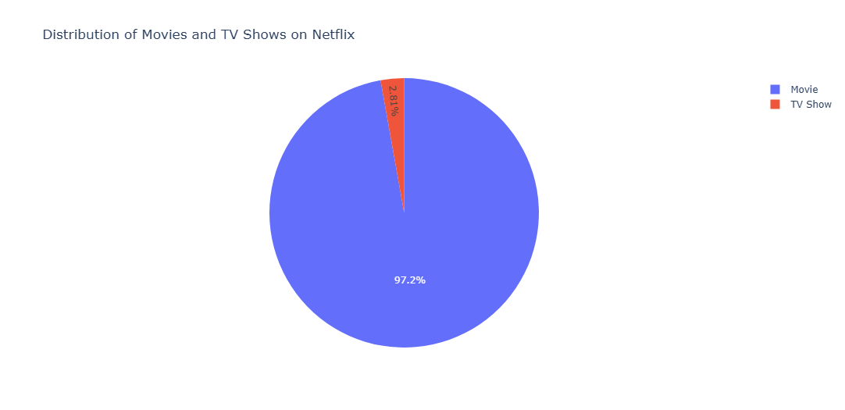
Netflix's content library primarily comprises movies, which account for 97.2% of the available titles. This translates to a total of 4,673 movies, significantly overshadowing the presence of TV shows. In comparison, TV shows make up only 2.8% of the collection, with a modest count of 135 titles.
This bar chart shows the number of titles released each year. We observe a significant rise in the number of titles after 2010, with a peak around 2018. This indicates Netflix's growing content library over time.

Figure 2: Top 5 Most Titles Directors
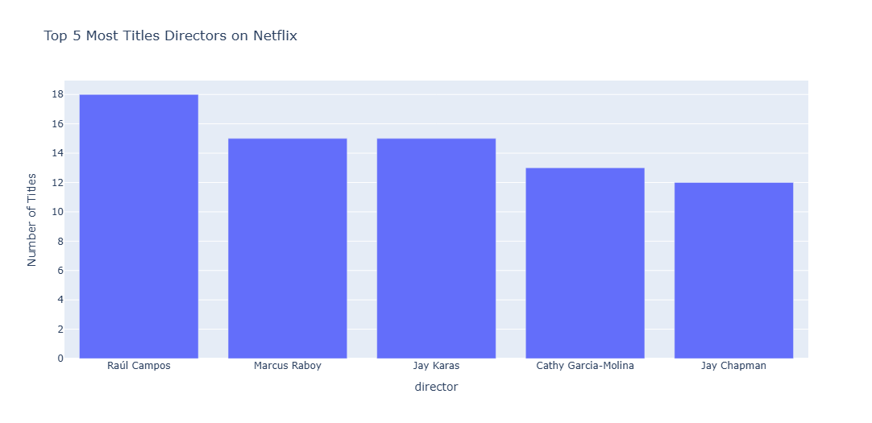
Top 5 Directors with the Most Titles on Netflix
Upon analyzing the Netflix dataset, the top five directors with the highest number of titles are as follows:
- Raúl Campos: 18 titles
- Marcus Raboy: 15 titles
- Jay Karas: 15 titles
- Cathy Garcia-Molina: 13 titles
- Jay Chapman: 12 titles
These directors have made significant contributions to Netflix's content library, showcasing their prolific work and impact on the entertainment industry.

Figure 3: Top 7 Most Common Genres
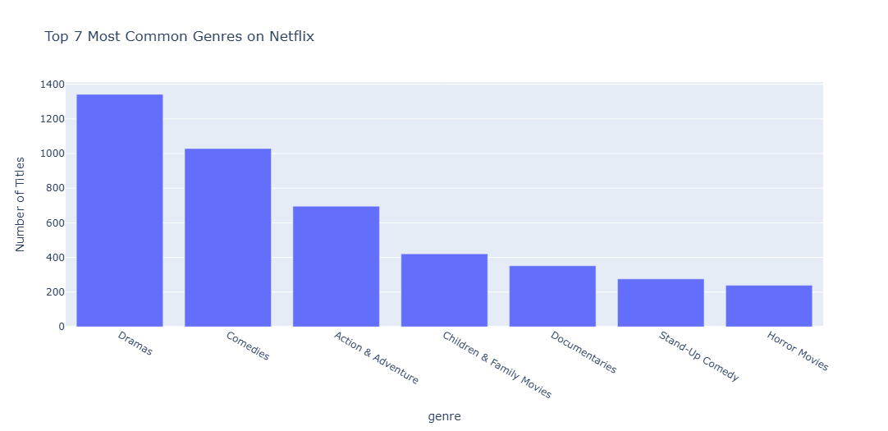
Top 7 Most Common Genres on Netflix
Based on an analysis of the Netflix dataset, the top seven most common genres are as follows:
- Dramas: 1,342 titles
- Comedies: 1,029 titles
- Action & Adventure: 696 titles
- Children & Family Movies: 421 titles
- Documentaries: 352 titles
- Stand-Up Comedy: 276 titles
- Horror Movies: 239 titles

Figure 4: Top Countries with the Most Content
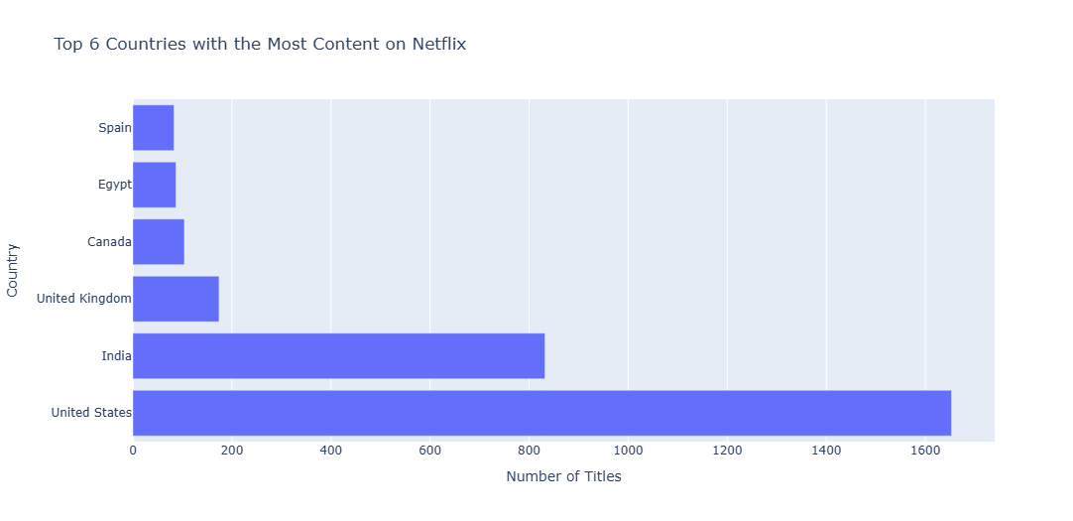
Top Countries with the Most Content on Netflix
The analysis of the Netflix dataset reveals the top countries contributing the most content to its library:
- United States: 1,653 titles
- India: 832 titles
- United Kingdom: 174 titles
- Canada: 104 titles
- Egypt: 87 titles
- Spain: 83 titles
These countries play a pivotal role in shaping Netflix's diverse content library, catering to a global audience with varied tastes and preferences.

Figure 5: Top 6 Content Ratings
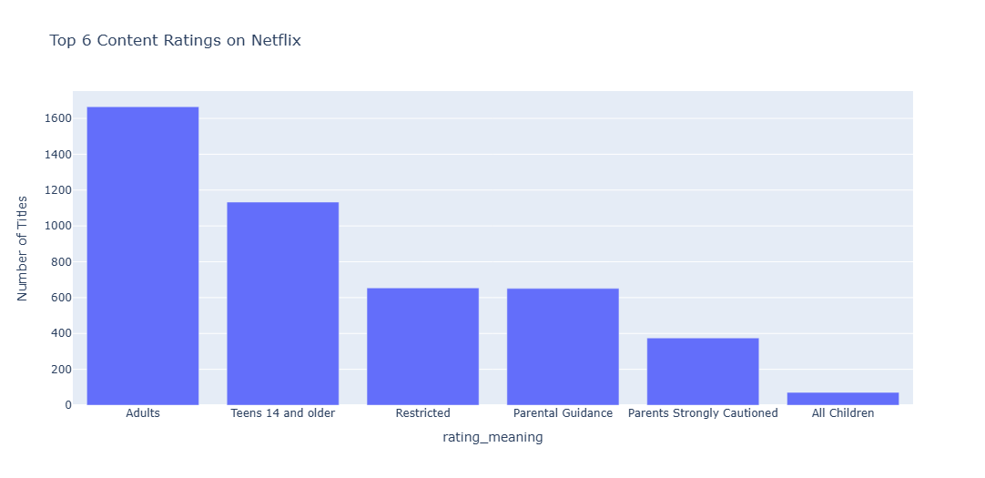
Top 6 Content Ratings on Netflix
The analysis of the Netflix dataset reveals the six most common content ratings, their meanings, and the respective number of titles:
- Adults (TV-MA): 1,665 titles
  - Suitable for mature audiences; not recommended for children.
- Teens 14 and older (TV-14): 1,133 titles
  - Appropriate for teenagers and older viewers.
- Restricted (R): 654 titles
  - Content typically requiring viewers to be 17+ or accompanied by an adult.
- Parental Guidance (TV-PG): 651 titles
  - Content where parental guidance is suggested for younger audiences.
- Parents Strongly Cautioned (PG-13): 375 titles
  - Indicates some material may be inappropriate for children under 13.
- All Children (TV-Y): 71 titles
  - Specifically designed to be suitable for young viewers.
These content ratings emphasize Netflix's commitment to providing diverse and age-appropriate choices, helping both viewers and parents make informed decisions.

Figure 6: Average Duration of Movies by Genre
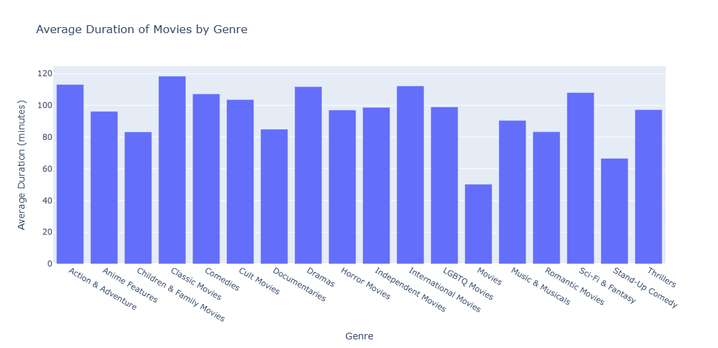
Average Duration of Movies by Genre
The table below provides the average duration (in minutes) of movies for each genre:
Genre | Average Duration (minutes)
Action & Adventure | 113.16
Anime Features | 96.22
Children & Family Movies | 83.24
Classic Movies | 118.43
Comedies | 107.18
Cult Movies | 103.64
Documentaries | 84.97
Dramas | 111.79
Horror Movies | 97.03
Independent Movies | 98.70
International Movies | 112.24
LGBTQ Movies | 99.00
Movies | 50.23
Music & Musicals | 90.50
Romantic Movies | 83.33
Sci-Fi & Fantasy | 108.09
Stand-Up Comedy | 66.56
Thrillers | 97.24

Analysis
Longer Movies:
- Classic Movies have the longest average duration, at approximately 118 minutes.
- Action & Adventure movies follow closely, averaging around 113 minutes.
Shorter Movies:
- Children & Family Movies and Romantic Movies are among the shortest, each averaging roughly 83 minutes.
- Stand-Up Comedy has a notably short average duration of 67 minutes.
Notable Anomaly:
- The category labeled "Movies" has an unusually short average duration of only 50 minutes, which could indicate a data issue or a mixed grouping requiring further investigation.
This analysis highlights how movie durations vary across genres, offering insights into the content's pacing and style.

Figure 7: Content Trends Over the Years on Netflix
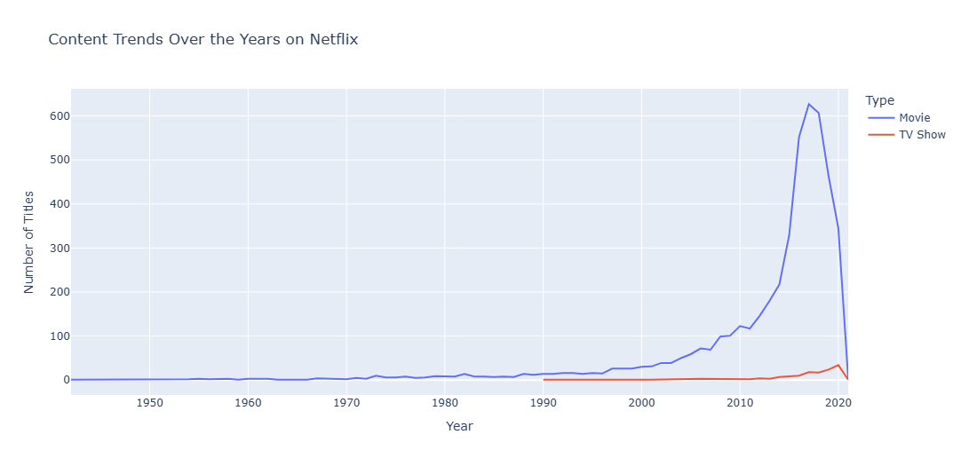
Content Trends Over the Years on Netflix
An analysis of the Netflix dataset reveals distinct trends in the number of titles added each year for movies and TV shows:
Movies
- The number of movies added to Netflix has grown significantly, particularly after 2010.
- A peak in the addition of titles was observed during 2018-2019, followed by a noticeable decline in subsequent years.
TV Shows
- The number of TV shows has shown a gradual increase over time.
- However, the growth rate for TV shows has been much slower compared to that of movies.

Figure 8: Number of Titles Released in India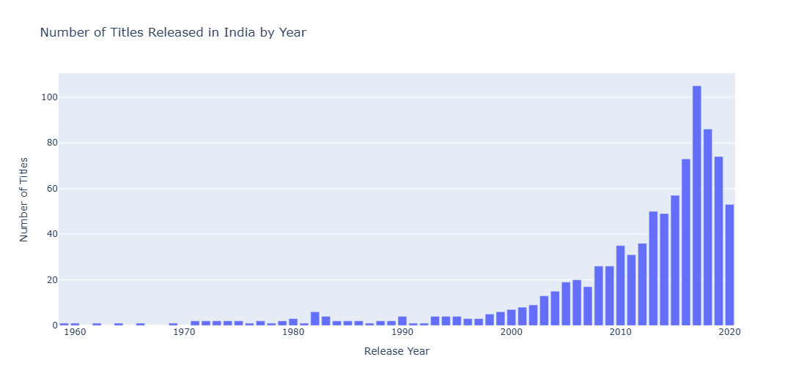
2017: 105 titles
Brief Explanation: The year 2017 marked the peak of India's content releases on Netflix, showcasing a significant focus on expanding the platform's offerings in the region.

Figure 9: Top 3 Genres in Content from India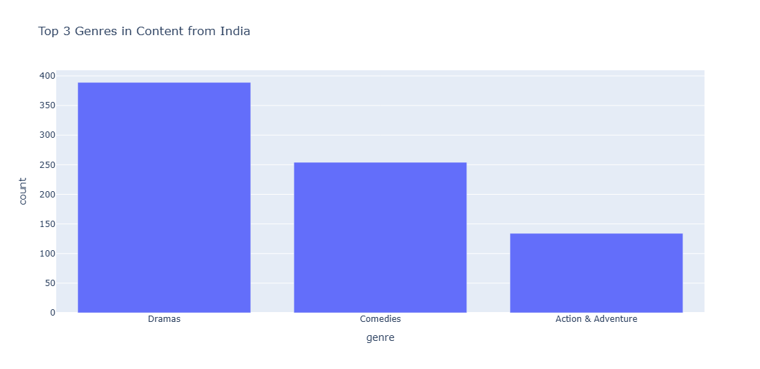
Top 3 Genres in Content from India
Genre | Count
Dramas | 389
Comedies | 254
Action & Adventure | 134
Brief Explanation: The table above shows the top 3 genres in Netflix's Indian content based on the number of titles available.
Dramas lead with 389 titles, showing that dramatic storytelling is very popular in the Indian segment.
Comedies come in second with 254 titles, indicating a strong interest in humorous content.
Action & Adventure completes the list with 134 titles, showcasing the demand for high-energy, thrilling content.

Figure 10: Titles Released by Year in the United States
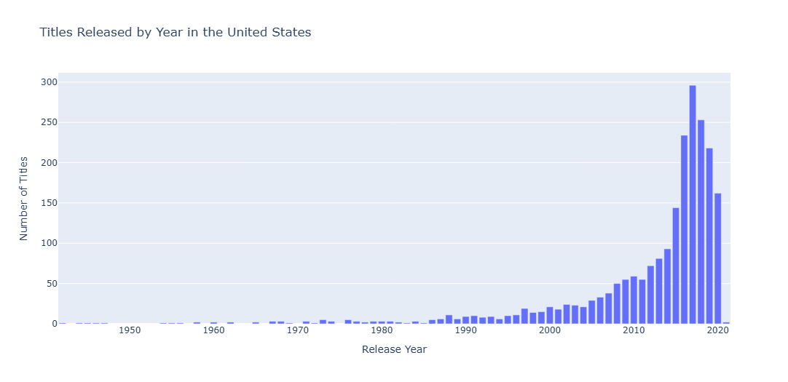

Step 0: Importing Libraries
import pandas as pd # Used for data manipulation and DataFrame operations
import numpy as np # Used for numerical operations and array manipulation
import plotly.express as px # Used for creating interactive visualizations
Step 1: Data Import and Overview
# Load the Netflix dataset into a pandas DataFrame

df = pd.read_csv('netflix_titles.csv') # Reading the CSV file into the DataFrame 'df'

# Display the first few rows of the dataset to get an overview

df.head() # This displays the first 5 rows of the DataFrame 'df'
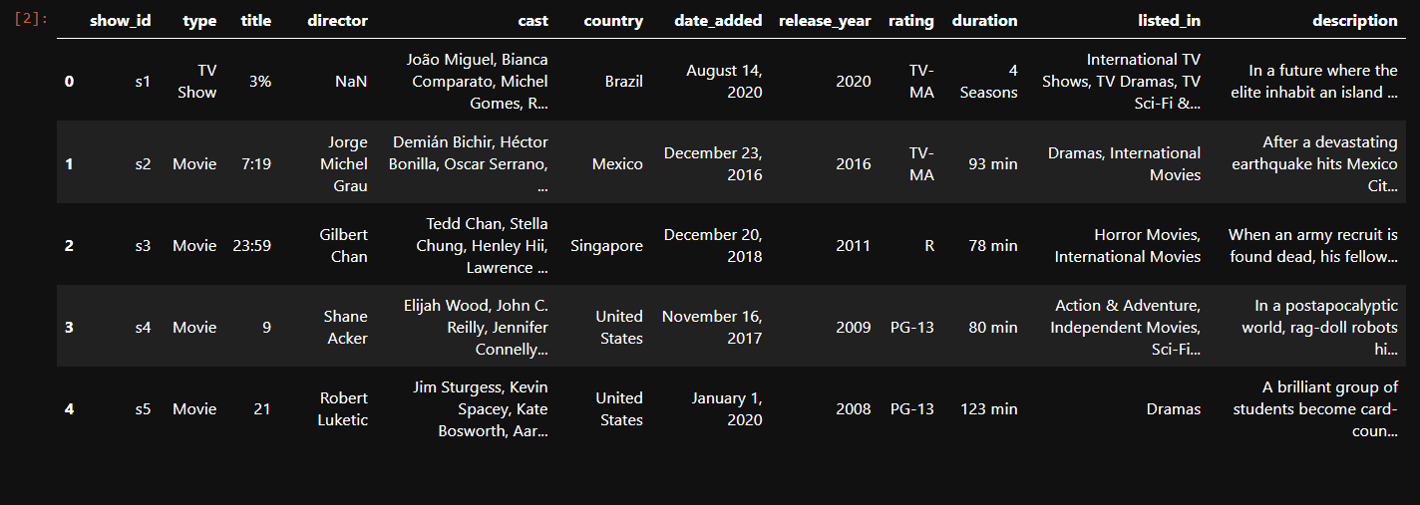

("Netflix Dataset Information")
This dataset provides details for Netflix movies and TV shows. Key columns include:
- Title: Name of the movie or TV show.
- Type: Movie or TV Show.
- Director & Cast: Main directors and actors.
- Country: Production country.
- Date Added: When it was added to Netflix.
- Release Year: Year of release.
- Rating: Audience rating (e.g., PG, R).
- Duration: Runtime for movies or number of seasons for TV shows.
- Genre: Category or style.
- Description: Short summary of the title.
This information is used to explore content trends and viewer preferences on Netflix.
Introduction: Evolution of Netflix Netflix began as a DVD rental service in 1997, co-founded by Reed Hastings and Marc Randolph. Initially, users rented DVDs online and had them delivered by mail—a groundbreaking idea at the time. In 2007, Netflix shifted its focus to video streaming, marking the beginning of a revolutionary era in the entertainment industry. This transition was driven by advancements in technology and the increasing accessibility of the internet.
Today, Netflix boasts over 230 million global subscribers (as of 2025). It offers a diverse catalog featuring thousands of movies, TV shows, documentaries, and its critically acclaimed original productions. From the Emmy-winning Stranger Things to Oscar-nominated films like Roma, Netflix's role in shaping modern entertainment is unparalleled.
The dataset I analyzed is a snapshot of Netflix’s content portfolio. It includes information such as titles, genres, release years, and duration, allowing for in-depth analysis of trends in streaming content

Step 2: Data Cleaning & Data Transformation

df.info()
- What it does: This function provides a concise summary of the dataset. It displays essential information like the number of rows and columns, column names, data types, and counts of non-null (valid) values for each column.
- Why it was used:
  - To understand the overall structure of the dataset at a glance.
  - To identify which columns have missing values or incorrect data types.
  - To determine the memory usage of the dataset, which can be important when working with large files.
- How it helped: Using df.info(), I identified missing or inconsistent values in the dataset, which guided the data-cleaning process.
df.sum()
- What it does: This function calculates the total (or sum) of numerical data in each column of the dataset. It can also concatenate strings if applied to text-based columns.
- Why it was used:
  - To calculate aggregate values, such as the total duration of content or the sum of numerical columns.
  - To identify overall trends, such as the cumulative runtime of all movies combined.
- How it helped: It provided insights into the dataset, like the total minutes of all movies, which reflect the sheer volume of content available on Netflix.

Removing Duplicate Data (df.drop_duplicates())
- What it does: This method removes duplicate rows from the dataset.
- Why it was used:
  - Duplicate data can distort the results of analyses by inflating counts or averages.
  - Cleaning the dataset ensures that all calculations and visualizations are based on unique entries.
- How it helped: Using df.drop_duplicates(), I ensured the dataset was free of duplicates, improving the accuracy of the analysis.

Removing Missing Values (df.dropna())
- What it does: This function removes rows or columns with missing (null) values.
- Why it was used:
  - Missing values can create issues in computations or visualizations.
  - Cleaning the dataset by removing null values ensures that the analysis is reliable and free from unexpected errors.
- How it helped: Dropping rows with missing values streamlined the dataset, making it easier to work with for subsequent steps.

Standardizing Data (df.rename(), df.apply())
- What it does:
  - df.rename() renames columns for better clarity.
  - df.apply() is a flexible method that applies a function to rows or columns, such as modifying text or numerical values.
- Why it was used:
  - Renaming columns like "listed_in" to "genre" improved readability and ensured that column names were intuitive.
  - Standardizing text values using df.apply() (e.g., converting titles or genres to lowercase) helped avoid inconsistencies.
- How it helped: These transformations ensured the dataset was consistent and easy to interpret during the analysis phase.

Extracting Data Parts (pd.to_datetime, .str.extract())
- What it does:
  - pd.to_datetime() converts date columns into a proper datetime format, allowing easy extraction of year, month, etc.
  - .str.extract() extracts specific patterns or substrings from text-based columns.
- Why it was used:
  - Converting the "date_added" column to datetime format enabled the extraction of the year Netflix added each title.
  - Extracting numerical values from the "duration" column helped isolate movie runtimes for analysis.
- How it helped: This made it possible to analyze trends by year and accurately compute averages for numerical columns like duration.

Counting Unique Values (value_counts())
- What it does: This method counts the occurrences of each unique value in a column, such as genres or countries.
- Why it was used:
  - To identify the most common genres, content ratings, or countries contributing titles.
  - To create visualizations like bar charts that highlight the distribution of content.
- How it helped: It provided key insights into Netflix's content strategy, such as which genres or countries dominate the platform.

# Display information about the DataFrame
df.info() # This provides a concise summary of the DataFrame, including column names, data types, and non-null values

<class 'pandas.core.frame.DataFrame'>
RangeIndex: 7787 entries, 0 to 7786
Data columns (total 12 columns):
# Column Non-Null Count Dtype
--- ------ -------------- -----
0 show_id 7787 non-null object
1 type 7787 non-null object
2 title 7787 non-null object
3 director 5398 non-null object
4 cast 7069 non-null object
5 country 7280 non-null object
6 date_added 7777 non-null object
7 release_year 7787 non-null int64
8 rating 7780 non-null object
9 duration 7787 non-null object
10 listed_in 7787 non-null object
11 description 7787 non-null object
dtypes: int64(1), object(11)
memory usage: 730.2+ KB
# Check for missing values in the DataFrame
df.isnull().sum() # This returns the count of missing values for each column in the DataFrame 'df'

show_id 0
type 0
title 0
director 2389
cast 718
country 507
date_added 10
release_year 0
rating 7
duration 0
listed_in 0
description 0
dtype: int64

# Drop rows with missing values
df = df.dropna() # This removes all rows with missing values from the DataFrame 'df'

df.isnull().sum() # This returns the count of missing values for each column in the DataFrame 'df'

show_id 0
type 0
title 0
director 0
cast 0
country 0
date_added 0
release_year 0
rating 0
duration 0
listed_in 0
description 0
dtype: int64

# Display information about the DataFrame
df.info() # This provides a concise summary of the DataFrame, including column names, data types, and non-null values

<class 'pandas.core.frame.DataFrame'>
Index: 4808 entries, 1 to 7783
Data columns (total 12 columns):
# Column Non-Null Count Dtype
--- ------ -------------- -----
0 show_id 4808 non-null object
1 type 4808 non-null object
2 title 4808 non-null object
3 director 4808 non-null object
4 cast 4808 non-null object
5 country 4808 non-null object
6 date_added 4808 non-null object
7 release_year 4808 non-null int64
8 rating 4808 non-null object
9 duration 4808 non-null object
10 listed_in 4808 non-null object
11 description 4808 non-null object
dtypes: int64(1), object(11)
memory usage: 488.3+ KB

# Drop multiple columns
df.drop(columns=['show_id', 'description'], inplace=True)

# Print column names
print(df.columns)

Index(['type', 'title', 'director', 'cast', 'country', 'date_added',
'release_year', 'rating', 'duration', 'listed_in'],
dtype='object')

# Convert to datetime type with format inference
df['date_added'] = pd.to_datetime(df['date_added'], format='mixed')

# Extract the year?
df['year_added'] = df['date_added'].dt.year

print(df.dtypes)

type object
title object
director object
cast object
country object
date_added datetime64[ns]
release_year int64
rating object
duration object
listed_in object
year_added int32
dtype: object

# Drop columns
df.drop(columns=['date_added'], inplace=True)

# Drop columns
df.drop(columns=['cast'], inplace=True)

# Display the first few rows of the dataset to get an overview
df.head() # This displays the first 5 rows of the DataFrame 'df'
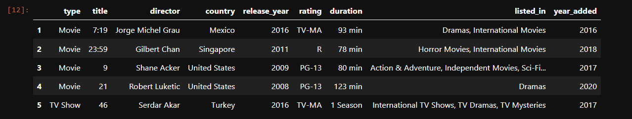
# Rename the column from 'listed_in' to 'genre'
df.rename(columns={'listed_in': 'genre'}, inplace=True)

# Check for duplicate rows
df.duplicated().sum() # This returns the count of duplicate rows in the DataFrame 'df'
np.int64(0)

# Split the genre and keep only the first genre
df['genre'] = df['genre'].apply(lambda x: x.split(', ')[0])

# Check for duplicate rows
df.duplicated().sum() # This returns the count of duplicate rows in the DataFrame 'df'

np.int64(0)

Step 3: Data Visualization
Visualizing Data (px.pie(), px.bar(), px.line())
- What it does:
  - px.pie(): Creates pie charts to show proportional data, such as the ratio of movies to TV shows.
  - px.bar(): Generates bar charts for comparisons, like the most common genres.
  - px.line(): Plots line graphs to display trends over time, such as the number of titles released per year.
- Why it was used: Visualization tools make it easier to communicate findings and identify trends in the data.
- How it helped: These plots transformed raw data into easy-to-understand visuals, highlighting patterns in Netflix’s content library.
Grouping Data (groupby())
- What it does: Groups data by one or more columns and applies aggregate functions, like sum or mean, to each group.
- Why it was used:
  - To analyze the average duration of movies by genre.
  - To study trends in the number of titles added per year.
- How it helped: Grouping by categories like "release_year" or "genre" provided deeper insights into patterns within the dataset.
Filtering Data (str.contains(), Conditional Indexing)
- What it does:
  - str.contains(): Filters rows where a specific string appears in a column, such as "India" in the "country" column.
  - Conditional indexing selects rows based on conditions, like movies released after 2015.
- Why it was used:
  - To focus on specific subsets of data, such as Indian content or recently released titles.
  - To analyze trends within specific categories.
- How it helped: Filtering the dataset allowed targeted analyses, such as identifying the top genres in Indian content or finding the peak year of content releases.
Handling Dates with pd.to_datetime()
- Purpose and Functionality: Converts date columns to datetime format for easier manipulation and extraction (e.g., extracting the year from "date_added").
- Why It Was Used:
  - To analyze the timeline of when content was added to Netflix.
  - To track trends over specific periods, such as growth in titles between 2015-2020.
- How It Helped:
  - Enabled year-wise grouping and visualizations.
  - Allowed analysis of how Netflix’s content catalog expanded over time.
value_counts() for Frequency Counts
- Purpose and Functionality: Counts the number of occurrences for each unique value in a column.
- Why It Was Used:
  - To identify dominant genres, like Drama and Comedy.
  - To rank countries based on the volume of content produced.
- How It Helped:
  - Provided clear summaries for building pie charts or bar graphs.
  - Highlighted key insights, such as the USA being the top contributor to Netflix content.

* Distribution of movies and TV shows on Netflix?
# Count the number of movies and TV shows
type_counts = df['type'].value_counts()

# Print the counts
print(type_counts)
type
Movie 4673
TV Show 135
Name: count, dtype: int64

# Create a pie chart using Plotly
fig = px.pie(values=type_counts.values, names=type_counts.index, title='Distribution of Movies and TV Shows on Netflix') # This creates a pie chart with the counts of Movies and TV Shows
fig.show()

Distribution of Movies and TV Shows on Netflix
Netflix's library is dominated by movies, with 4,673 titles (97.2%) of the content. TV shows make up only 135 titles (2.8%) of the collection.

Which 5 directors have the most titles on Netflix?
Clean the Data: Ensure that we clean any white spaces after the comma in the director names.

# Extract the first director's name and strip any white spaces
df['director'] = df['director'].apply(lambda x: x.split(',')[0].strip())

Use pandas to count the number of titles directed by each director.

# Count the number of titles directed by each director
director_counts = df['director'].value_counts().head(5)

#print(director_counts)

# Create a bar chart using Plotly
fig = px.bar(director_counts, x=director_counts.index, y=director_counts.values, labels={'x': 'Director', 'y': 'Number of Titles'}, title='Top 5 Most Titles Directors on Netflix') # This creates a pie chart with the counts of Movies and TV Shows

# Display the pie chart
fig.show()

Top 5 Directors with the Most Titles on Netflix

Upon analyzing the Netflix dataset, the top 5 directors with the most titles are identified as follows:
- Raúl Campos: 18 titles
- Marcus Raboy: 15 titles
- Jay Karas: 15 titles
- Cathy Garcia-Molina: 13 titles
- Jay Chapman: 12 titles
These directors have contributed a lot to Netflix's content library, showcasing their significant work in the entertainment industry.

What are the most common genres for movies and TV shows on Netflix?

# Count the number of titles in each genre
genre_counts = df.genre.value_counts().head(7)
#print(genre_counts)

# Create a bar chart using Plotly
fig = px.bar(genre_counts, x=genre_counts.index, y=genre_counts.values, labels={'x': 'Genre', 'y': 'Number of Titles'}, title='Top 7 Most Common Genres on Netflix')
fig.show()

Top 7 Most Common Genres on Netflix
After analyzing the Netflix dataset, the top 7 most common genres are identified as follows:
- Dramas: 1,342 titles
- Comedies: 1,029 titles
- Action & Adventure: 696 titles
- Children & Family Movies: 421 titles
- Documentaries: 352 titles
- Stand-Up Comedy: 276 titles
- Horror Movies: 239 titles
These genres highlight the diverse range of entertainment options available to Netflix viewers.

Which countries have the most content on Netflix?
# Count the number of titles from each country
country_counts = df.country.value_counts().head(6).reset_index()
country_counts.columns = ['Country', 'Number of Titles']

#country_counts

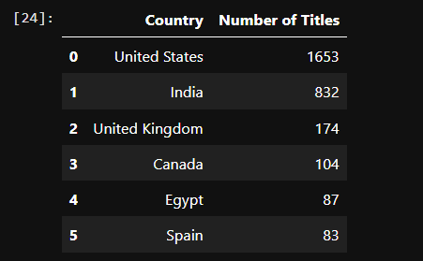
# Create a horizontal bar chart using Plotly
fig = px.bar(country_counts, x='Number of Titles', y='Country', orientation='h', labels={'Number of Titles': 'Number of Titles', 'Country': 'Country'}, title='Top 6 Countries with the Most Content on Netflix')
fig.show()

Top Countries with the Most Content on Netflix
Upon analyzing the Netflix dataset, the top countries by content count are as follows:
- United States: 1,653 titles
- India: 832 titles
- United Kingdom: 174 titles
- Canada: 104 titles
- Egypt: 87 titles
- Spain: 83 titles
These countries contribute significantly to Netflix's diverse content library.

What is the distribution of different content ratings (like PG, PG-13, R, etc.) on Netflix?
Create a dictionary to map the ratings to their real meanings.

rating_meanings = {
'TV-MA': 'Adults',
'TV-14': 'Teens 14 and older',
'TV-PG': 'Parental Guidance',
'TV-Y7': 'Children 7 and older',
'TV-Y': 'All Children',
'R': 'Restricted',
'PG-13': 'Parents Strongly Cautioned',
'PG': 'Parental Guidance',
'G': 'General Audiences',
'NR': 'Not Rated',
'UR': 'Unrated'
}

# Map the ratings to their meanings
df['rating_meaning'] = df['rating'].map(rating_meanings)

# Count the number of titles for each rating meaning
rating_meaning_counts = df['rating_meaning'].value_counts().head(6)
print(rating_meaning_counts)
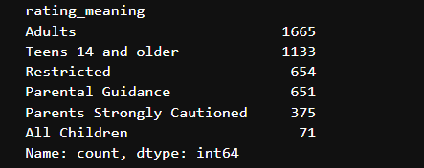

# Create a bar chart using Plotly
fig = px.bar(rating_meaning_counts, x=rating_meaning_counts.index, y=rating_meaning_counts.values, labels={'x': 'Rating Meaning', 'y': 'Number of Titles'}, title='Top 6 Content Ratings on Netflix')
fig.show()

Top 6 Content Ratings on Netflix
Upon analyzing the Netflix dataset, the top 6 content ratings along with their meanings and respective title counts are as follows:
- Adults (TV-MA): 1,665 titles
Suitable for mature audiences; not recommended for children.
- Teens 14 and older (TV-14): 1,133 titles
Appropriate for teenagers and older viewers.
- Restricted (R): 654 titles
Movies and shows that typically require viewers to be 17+ or accompanied by an adult.
- Parental Guidance (TV-PG): 651 titles
May contain content that parental guidance is suggested for young children.
- Parents Strongly Cautioned (PG-13): 375 titles
Indicates that some material may be inappropriate for children under 13.
- All Children (TV-Y): 71 titles
Designed to be suitable for young viewers.
These ratings highlight the diverse range of age-appropriate content available on Netflix, helping viewers and parents make informed choices.

What is the average duration of movies? How does it vary by genre?

# Extract the numerical part of the duration and convert to integers
df['duration'] = df['duration'].str.extract(r'(\d+)').astype(int) #can run one time already runed
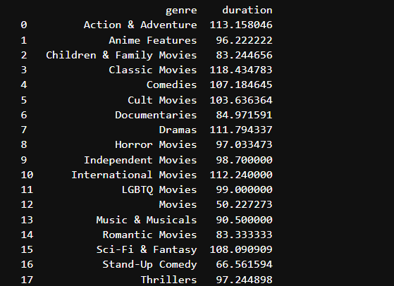
# Create a bar chart using Plotly for movies only
fig = px.bar(
average_duration,
x='genre',
y='duration',
labels={'genre': 'Genre', 'duration': 'Average Duration (minutes)'},
title='Average Duration of Movies by Genre'
)
fig.show()

Average Duration of Movies by Genre

Analysis
- Longer Movies:
  - Classic Movies average about 118 minutes.
  - Action & Adventure movies are also relatively long at around 113 minutes.
- Shorter Movies:
  - Children & Family Movies and Romantic Movies tend to be on the shorter side, averaging roughly 83 minutes.
  - Stand-Up Comedy movies average about 67 minutes.
- Notable Anomaly:
  - The category labeled just "Movies" has an average duration of only 50 minutes, which is unusually short compared to other genres. This might indicate a data issue or a mixed grouping that needs further investigation.
This breakdown helps in understanding how movie durations vary by genre, giving insights into the content's style and pacing.

How has the number of movies and TV shows added each year changed over time?

# Group by release year and type, and count the number of titles
yearly_trends = df.groupby(['release_year', 'type']).size().reset_index(name='num_titles')
print(yearly_trends)

<class 'pandas.core.frame.DataFrame'>
RangeIndex: 7787 entries, 0 to 7786
Data columns (total 12 columns):
# Column Non-Null Count Dtype
--- ------ -------------- -----
df.isnull().sum()

0 show_id 7787 non-null object
1 type 7787 non-null object
2 title 7787 non-null object
3 director 5398 non-null object
4 cast 7069 non-null object
5 country 7280 non-null object
6 date_added 7777 non-null object
7 release_year 7787 non-null int64
8 rating 7780 non-null object
9 duration 7787 non-null object
10 listed_in 7787 non-null object
11 description 7787 non-null object
dtypes: int64(1), object(11)
memory usage: 730.2+ KB

show_id 0
type 0
title 0
director 2389
cast 718
country 507
date_added 10
release_year 0
rating 7
duration 0
listed_in 0
description 0
dtype: int64

df = df.dropna()

show_id 0
type 0
title 0
director 0
cast 0
country 0
date_added 0
release_year 0
rating 0
duration 0
listed_in 0
description 0
dtype: int64

df.info()
<class 'pandas.core.frame.DataFrame'>
Index: 4808 entries, 1 to 7783
Data columns (total 12 columns):
# Column Non-Null Count Dtype
--- ------ -------------- -----
0 show_id 4808 non-null object
1 type 4808 non-null object
2 title 4808 non-null object
3 director 4808 non-null object
4 cast 4808 non-null object
5 country 4808 non-null object
6 date_added 4808 non-null object
7 release_year 4808 non-null int64
8 rating 4808 non-null object
9 duration 4808 non-null object
10 listed_in 4808 non-null object
11 description 4808 non-null object
dtypes: int64(1), object(11)
memory usage: 488.3+ KB

df["listed_in"].unique()

array(['Dramas, International Movies',
'Horror Movies, International Movies',
'Action & Adventure, Independent Movies, Sci-Fi & Fantasy',
'Dramas', 'International TV Shows, TV Dramas, TV Mysteries',
'Horror Movies, International Movies, Thrillers',
'Dramas, Thrillers',
'Documentaries, International Movies, Sports Movies',
'Independent Movies, Sci-Fi & Fantasy, Thrillers',
'Dramas, International Movies, Thrillers',
'Comedies, Dramas, Independent Movies',
'Dramas, Independent Movies, International Movies',
'Action & Adventure, Dramas, International Movies',
'Documentaries, International Movies',
'Dramas, International Movies, Romantic Movies', 'Comedies',
'Comedies, Romantic Movies',
'Comedies, Dramas, International Movies',
'Comedies, International Movies',
'Action & Adventure, Sci-Fi & Fantasy', 'Dramas, Romantic Movies',
'Dramas, Romantic Movies, Sports Movies',
'Comedies, International Movies, Romantic Movies',
'Action & Adventure',
'Dramas, International Movies, Sports Movies',
'Dramas, Independent Movies, Sports Movies',
'Horror Movies, Independent Movies, Thrillers',
'Horror Movies, Thrillers',
'Action & Adventure, International Movies',
'Horror Movies, Independent Movies',
'Documentaries, Music & Musicals', 'Sci-Fi & Fantasy',
'Dramas, Independent Movies',
'Action & Adventure, Comedies, International Movies',
'Documentaries', 'Comedies, Dramas', 'Dramas, LGBTQ Movies',
'Action & Adventure, Comedies', 'International Movies, Thrillers',
'Children & Family Movies, Comedies', 'Comedies, LGBTQ Movies',
'Comedies, Dramas, Romantic Movies', 'Action & Adventure, Dramas',
'Dramas, Independent Movies, Romantic Movies',
'Comedies, Independent Movies, Thrillers', 'TV Shows',
'Comedies, International Movies, Music & Musicals',
'Children & Family Movies, Dramas, Sports Movies',
'Children & Family Movies', 'Dramas, Sci-Fi & Fantasy',
'Action & Adventure, Classic Movies, Dramas',
'Children & Family Movies, Dramas',
'Action & Adventure, International Movies, Romantic Movies',
'Children & Family Movies, Dramas, Romantic Movies', 'Movies',
'Children & Family Movies, Comedies, Music & Musicals',
'Classic Movies, Cult Movies, Dramas',
'Action & Adventure, International Movies, Sci-Fi & Fantasy',
'Comedies, Independent Movies', 'Comedies, Horror Movies',
'Children & Family Movies, Comedies, Romantic Movies',
'Documentaries, Sports Movies', 'Thrillers',
'Comedies, International Movies, Sports Movies',
'Dramas, LGBTQ Movies, Romantic Movies', 'Comedies, Cult Movies',
'Dramas, Independent Movies, LGBTQ Movies',
'International TV Shows, Reality TV', 'Stand-Up Comedy',
'Anime Features, International Movies',
'Music & Musicals, Romantic Movies', 'Comedies, Music & Musicals',
'International Movies, Romantic Movies',
'Anime Features, Children & Family Movies, International Movies',
'Anime Series, International TV Shows', 'Horror Movies',
'Action & Adventure, Children & Family Movies, Independent Movies',
'Dramas, International Movies, Music & Musicals', "Kids' TV",
'Comedies, International Movies, Sci-Fi & Fantasy',
'International TV Shows, Korean TV Shows, Stand-Up Comedy & Talk Shows',
'Dramas, Sports Movies',
'Dramas, Music & Musicals, Romantic Movies',
'Children & Family Movies, Comedies, International Movies',
'Action & Adventure, Documentaries, International Movies',
'Crime TV Shows, Romantic TV Shows, TV Dramas'], dtype=object)

Extract the Unique Values: Use the unique() function to find all unique values in the listed_in column.

# Split the genres into lists
df['genre_list'] = df['listed_in'].str.split(r',\s*')

# Flatten the list of lists and convert to a set to find unique genres
unique_genres_set = set([genre for sublist in df['genre_list'] for genre in sublist])

# Convert set back to list if needed
unique_genres_list = list(unique_genres_set)
print(unique_genres_list)
['LGBTQ Movies', 'Docuseries', 'Horror Movies', 'Sports Movies', 'Thrillers', 'TV Comedies', 'Romantic Movies', 'TV Sci-Fi & Fantasy', 'TV Shows', 'International Movies', 'Cult Movies', 'Teen TV Shows', 'TV Mysteries', 'Anime Series', 'Action & Adventure', 'Independent Movies', 'Documentaries', 'British TV Shows', 'International TV Shows', 'Romantic TV Shows', 'Children & Family Movies', 'Reality TV', 'Stand-Up Comedy', 'TV Dramas', 'Dramas', 'Crime TV Shows', 'Stand-Up Comedy & Talk Shows', 'Movies', 'TV Horror', 'TV Thrillers', 'Comedies', 'Korean TV Shows', 'Classic Movies', 'TV Action & Adventure', 'Science & Nature TV', 'Music & Musicals', 'Anime Features', "Kids' TV", 'Classic & Cult TV', 'Sci-Fi & Fantasy', 'Faith & Spirituality', 'Spanish-Language TV Shows']

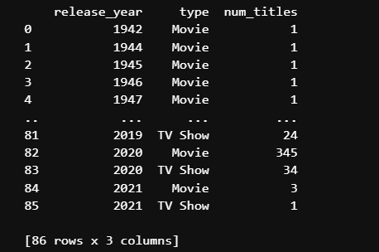

# Create a line chart using Plotly
fig = px.line(yearly_trends, x='release_year', y='num_titles', color='type', labels={'release_year': 'Year', 'num_titles': 'Number of Titles', 'type': 'Type'}, title='Content Trends Over the Years on Netflix')
fig.show()

Content Trends Over the Years on Netflix
After analyzing the Netflix dataset, the trends in the number of titles added each year are as follows:
Movies
- The number of movies added has significantly increased, especially after 2010.
- There was a peak in titles around 2018-2019, followed by a sharp decline.
TV Shows
- The number of TV shows has also increased over the years, but at a much slower rate compared to movies.
The line graph illustrates these trends by showing the growth and fluctuations in the types of content added to Netflix over the years.

"In which year did India release the highest number of titles on Netflix?"

# Filter the dataset for titles produced in India
india_data = df[df['country'].str.contains("India", na=False, case=False)]

# Count the number of titles released each year in India
year_counts = india_data['release_year'].value_counts().reset_index()
year_counts.columns = ['release_year', 'num_titles']

# Find the year with the highest number of titles
top_year = year_counts.loc[year_counts['num_titles'].idxmax()
print(f"The year India released the highest number of titles is {top_year['release_year']} with {top_year['num_titles']} titles.")
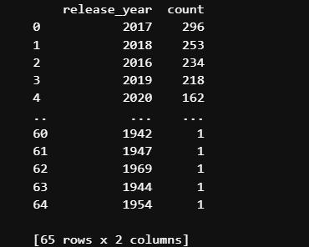
# Create a bar chart to visualize the number of titles by year
fig = px.bar(year_counts, x='release_year', y='num_titles',
title="Number of Titles Released in India by Year",
labels={'release_year': 'Release Year', 'num_titles': 'Number of Titles'})

fig.show()

Answer:
- 2017: 105 titles
Brief Explanation:
The year 2017 marked the peak of India's content releases on Netflix, showcasing a significant focus on expanding the platform's offerings in the region.

What are the top 3 most common genres in content from India?
# Filter the dataset for titles from India
india_data = df[df['country'].str.contains("India", na=False, case=False)]

# Get the top 3 genres
top_genres = india_data['genre'].value_counts().head(3).reset_index()

print(top_genres)

# Create and show the bar chart
fig = px.bar(top_genres, x='genre', y='count', title='Top 3 Genres in Content from India')
fig.show()
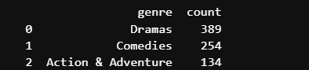
Top 3 Genres in Content from India

Brief Explanation:
The table above shows the top 3 genres in Netflix's Indian content based on the number of titles available.
Dramas lead with 389 titles, suggesting that dramatic storytelling is highly prevalent in the Indian segment.
Comedies come in second with 254 titles, indicating a strong presence of humorous content.
Action & Adventure rounds out the list with 134 titles, highlighting that high-energy and thrilling content is also popular.

Which year had the highest number of titles released in the United States on Netflix?

# Filter the dataset for entries with "United States" in the country column
us_data = df[df['country'].str.contains("United States", na=False, case=False)]

# Count the number of titles released each year
year_counts = us_data['release_year'].value_counts().reset_index()

# Create a simple bar chart using Plotly Express
fig = px.bar(
year_counts,
x='release_year',
y='count',
title='Titles Released by Year in the United States',
labels={'release_year': 'Release Year', 'count': 'Number of Titles'}
)

fig.show()

#Explode the list so that each genre gets its own row

genres_exploded = df.explode('genre_list')

#Count the occurrences of each genre

genre_counts = genres_exploded['genre_list'].value_counts()

print(genre_counts)

genre_list
International Movies 2178
Dramas 2038
Comedies 1405
Action & Adventure 696
Independent Movies 666
Romantic Movies 511
Thrillers 477
Children & Family Movies 450
Documentaries 370
Horror Movies 302
Stand-Up Comedy 283
Music & Musicals 263
Sci-Fi & Fantasy 211
Sports Movies 147
Classic Movies 95
International TV Shows 78
LGBTQ Movies 73
Cult Movies 57
Anime Features 55
Faith & Spirituality 51
TV Dramas 48
Crime TV Shows 34
TV Comedies 26
Movies 22
British TV Shows 20
Romantic TV Shows 17
Docuseries 14
Kids' TV 13
TV Action & Adventure 11
Spanish-Language TV Shows 11
Stand-Up Comedy & Talk Shows 11
Anime Series 9
Korean TV Shows 9
TV Mysteries 8
TV Horror 6
TV Shows 4
TV Sci-Fi & Fantasy 4
Reality TV 3
Teen TV Shows 3
TV Thrillers 3
Classic & Cult TV 3
Science & Nature TV 1
Name: count, dtype: int64

#Convert the 'date_added' column to datetime format

df["date_added"] = pd.to_datetime(df["date_added"], errors='coerce', )

#Extract the year from the 'date_added' column

df["year_added"] = df["date_added"].dt.year

#Fill NaN values using forward fill

df['year_added'] = df['year_added'].ffill()

#Group by the year and count the number of titles added each year

titles_per_year = df.groupby("year_added").size()

# Convert the 'year_added' column to integer

df["year_added"] = df["year_added"].astype(int)

#Check for unparsed dates (NaT values)

unparsed_dates = df[df['date_added'].isna()]

print("Unparsed Dates:")
print(unparsed_dates)

Unparsed Dates:
show_id type title director \
284 s285 TV Show Abnormal Summit Jung-ah Im, Seung-uk Jo
2130 s2131 TV Show Father Brown Ian Barber
3951 s3952 TV Show Mars Everardo Gout
5291 s5292 TV Show Royal Pains Jay Chandrasekhar

cast country \
284 Hyun-moo Jun, Si-kyung Sung, Se-yoon Yoo South Korea
2130 Mark Williams, Sorcha Cusack, Nancy Carroll, A... United Kingdom
3951 Jihae, Alberto Ammann, Clémentine Poidatz, Ana... United States
5291 Mark Feuerstein, Paulo Costanzo, Reshma Shetty... United States

date_added release_year rating duration \
284 NaT 2017 TV-PG 2 Seasons
2130 NaT 2017 TV-14 6 Seasons
3951 NaT 2018 TV-PG 2 Seasons
5291 NaT 2016 TV-PG 8 Seasons

listed_in \
284 International TV Shows, Korean TV Shows, Stand...
2130 British TV Shows, Crime TV Shows, TV Dramas
3951 Docuseries, Science & Nature TV, TV Dramas
5291 TV Comedies, TV Dramas

description \
284 Led by a trio of Korean celebs, a multinationa...
2130 A modest, compassionate priest doubles as an e...
3951 Fact meets fiction in this docudrama chronicli...
5291 Dr. Hank Lawson unexpectedly gets a career upg...

genre_list year_added
284 [International TV Shows, Korean TV Shows, Stan... 2018
2130 [British TV Shows, Crime TV Shows, TV Dramas] 2020
3951 [Docuseries, Science & Nature TV, TV Dramas] 2019
5291 [TV Comedies, TV Dramas] 2018

#Output the DataFrame with parsed dates

print("DataFrame with Parsed Dates:")
print(df)

DataFrame with Parsed Dates:
show_id type title director \
1 s2 Movie 7:19 Jorge Michel Grau
2 s3 Movie 23:59 Gilbert Chan
3 s4 Movie 9 Shane Acker
4 s5 Movie 21 Robert Luketic
5 s6 TV Show 46 Serdar Akar
... ... ... ... ...
7778 s7779 Movie Zombieland Ruben Fleischer
7780 s7781 Movie Zoo Shlok Sharma
7781 s7782 Movie Zoom Peter Hewitt
7782 s7783 Movie Zozo Josef Fares
7783 s7784 Movie Zubaan Mozez Singh

cast \
1 Demián Bichir, Héctor Bonilla, Oscar Serrano, ...
2 Tedd Chan, Stella Chung, Henley Hii, Lawrence ...
3 Elijah Wood, John C. Reilly, Jennifer Connelly...
4 Jim Sturgess, Kevin Spacey, Kate Bosworth, Aar...
5 Erdal Beşikçioğlu, Yasemin Allen, Melis Birkan...
... ...
7778 Jesse Eisenberg, Woody Harrelson, Emma Stone, ...
7780 Shashank Arora, Shweta Tripathi, Rahul Kumar, ...
7781 Tim Allen, Courteney Cox, Chevy Chase, Kate Ma...
7782 Imad Creidi, Antoinette Turk, Elias Gergi, Car...
7783 Vicky Kaushal, Sarah-Jane Dias, Raaghav Chanan...

country date_added \
1 Mexico 2016-12-23
2 Singapore 2018-12-20
3 United States 2017-11-16
4 United States 2020-01-01
5 Turkey 2017-07-01
... ... ...
7778 United States 2019-11-01
7780 India 2018-07-01
7781 United States 2020-01-11
7782 Sweden, Czech Republic, United Kingdom, Denmar... 2020-10-19
7783 India 2019-03-02

release_year rating duration \
1 2016 TV-MA 93 min
2 2011 R 78 min
3 2009 PG-13 80 min
4 2008 PG-13 123 min
5 2016 TV-MA 1 Season
... ... ... ...
7778 2009 R 88 min
7780 2018 TV-MA 94 min
7781 2006 PG 88 min
7782 2005 TV-MA 99 min
7783 2015 TV-14 111 min

listed_in \
1 Dramas, International Movies
2 Horror Movies, International Movies
3 Action & Adventure, Independent Movies, Sci-Fi...
4 Dramas
5 International TV Shows, TV Dramas, TV Mysteries
... ...
7778 Comedies, Horror Movies
7780 Dramas, Independent Movies, International Movies
7781 Children & Family Movies, Comedies
7782 Dramas, International Movies
7783 Dramas, International Movies, Music & Musicals

description \
1 After a devastating earthquake hits Mexico Cit...
2 When an army recruit is found dead, his fellow...
3 In a postapocalyptic world, rag-doll robots hi...
4 A brilliant group of students become card-coun...
5 A genetics professor experiments with a treatm...
... ...
7778 Looking to survive in a world taken over by zo...
7780 A drug dealer starts having doubts about his t...
7781 Dragged from civilian life, a former superhero...
7782 When Lebanon's Civil War deprives Zozo of his ...
7783 A scrappy but poor boy worms his way into a ty...

genre_list year_added
1 [Dramas, International Movies] 2016
2 [Horror Movies, International Movies] 2018
3 [Action & Adventure, Independent Movies, Sci-F... 2017
4 [Dramas] 2020
5 [International TV Shows, TV Dramas, TV Mysteries] 2017
... ... ...
7778 [Comedies, Horror Movies] 2019
7780 [Dramas, Independent Movies, International Mov... 2018
7781 [Children & Family Movies, Comedies] 2020
7782 [Dramas, International Movies] 2020
7783 [Dramas, International Movies, Music & Musicals] 2019

[4808 rows x 14 columns]

print(df['year_added'])
1 2016
2 2018
3 2017
4 2020
5 2017
...
7778 2019
7780 2018
7781 2020
7782 2020
7783 2019
Name: year_added, Length: 4808, dtype: int64

# Assuming you have a DataFrame named df
df['first_cast'] = df['cast'].str.split(', ').str[0]

# Display the DataFrame with the new column
print(df[['cast', 'first_cast']])

cast first_cast
1 Demián Bichir, Héctor Bonilla, Oscar Serrano, ... Demián Bichir
2 Tedd Chan, Stella Chung, Henley Hii, Lawrence ... Tedd Chan
3 Elijah Wood, John C. Reilly, Jennifer Connelly... Elijah Wood
4 Jim Sturgess, Kevin Spacey, Kate Bosworth, Aar... Jim Sturgess
5 Erdal Beşikçioğlu, Yasemin Allen, Melis Birkan... Erdal Beşikçioğlu
... ... ...
7778 Jesse Eisenberg, Woody Harrelson, Emma Stone, ... Jesse Eisenberg
7780 Shashank Arora, Shweta Tripathi, Rahul Kumar, ... Shashank Arora
7781 Tim Allen, Courteney Cox, Chevy Chase, Kate Ma... Tim Allen
7782 Imad Creidi, Antoinette Turk, Elias Gergi, Car... Imad Creidi
7783 Vicky Kaushal, Sarah-Jane Dias, Raaghav Chanan... Vicky Kaushal

[4808 rows x 2 columns]
Data Loading and Initial Inspection
- pd.read_csv('filename.csv')
  - What it does: Reads data from a Comma Separated Values (CSV) file into a Pandas DataFrame.
  - Why it was used: To load your netflix_titles.csv dataset into a DataFrame named df, which is the primary structure for manipulating and analyzing data in Pandas.
  - Example: df = pd.read_csv('netflix_titles.csv')
- df.head()
  - What it does: Displays the first few rows (default is 5) of the DataFrame.
  - Why it was used: To get a quick look at the dataset's structure, column names, and the type of data in each column after loading it.
  - Example: df.head()
- df.info()
  - What it does: Provides a concise summary of the DataFrame, including the number of entries, column names, data types of each column, and the count of non-null values.
  - Why it was used: To understand the dataset's overall structure, check data types, identify columns with missing values, and get an idea of memory usage.
  - Example: df.info()
- df.isnull().sum()
  - What it does: First, df.isnull() creates a DataFrame of boolean values (True for missing/null, False otherwise). Then, .sum() counts the number of True values (missing values) in each column.
  - Why it was used: To identify and count how many missing values exist in each column of your dataset, which is crucial for data cleaning.
  - Example: df.isnull().sum()
Data Cleaning and Transformation
- df.dropna()
  - What it does: Removes rows (or columns) containing missing (NaN/null) values.
  - Why it was used: To clean the dataset by removing rows with missing information, ensuring more reliable analysis and preventing errors during calculations or visualizations.
  - Example: df = df.dropna()
- df.drop_duplicates()
  - What it does: Removes duplicate rows from the DataFrame.
  - Why it was used: To ensure that each row represents a unique entry, preventing skewed results in analyses like counts or averages.
  - Example: (While the function call df.drop_duplicates() is mentioned in the explanation, the actual usage example shown checks the sum of duplicates: df.duplicated().sum() )
- df.drop(columns=['col1', 'col2'], inplace=True)
  - What it does: Removes specified columns from the DataFrame. inplace=True modifies the DataFrame directly without needing to reassign it.
  - Why it was used: To remove columns that were not needed for your specific analysis, like 'show_id' and 'description', and later 'date_added' and 'cast', simplifying the dataset.
  - Example: df.drop(columns=['show_id', 'description'], inplace=True)
- pd.to_datetime(df['column'], format='mixed')
  - What it does: Converts a column containing date-like strings into a proper datetime format, allowing for date-based operations. format='mixed' attempts to infer the format of different date strings.
  - Why it was used: To convert the date_added column into a standard datetime format so you could easily extract the year it was added for trend analysis.
  - Example: df['date_added'] = pd.to_datetime(df['date_added'], format='mixed') (Note: The report also shows errors='coerce' in another section )
- df['column'].dt.year
  - What it does: When applied to a column with datetime objects, it extracts the year component from each date.
  - Why it was used: To create a new year_added column from the cleaned date_added column, facilitating analysis of trends over the years.
  - Example: df['year_added'] = df['date_added'].dt.year
- df.rename(columns={'old_name': 'new_name'}, inplace=True)
  - What it does: Renames one or more columns in the DataFrame.
  - Why it was used: To make column names more intuitive and readable, specifically changing 'listed_in' to 'genre'.
  - Example: df.rename(columns={'listed_in': 'genre'}, inplace=True)
- df['column'].apply(lambda x: function(x))
  - What it does: Applies a function along an axis of the DataFrame. Often used with a lambda (anonymous) function for custom transformations on a column.
  - Why it was used: To perform custom operations, like splitting the genre string by commas and keeping only the first genre listed, simplifying the genre analysis. It was also used to extract the first director's name.
  - Example: df['genre'] = df['genre'].apply(lambda x: x.split(', ')[0])
- df['column'].str.split(', ').str[0]
  - What it does: A string manipulation method. .str.split(', ') splits strings in the column by the delimiter ', '. .str[0] then selects the first element from the resulting list.
  - Why it was used: As an alternative or complement to .apply(), specifically shown for extracting the first_cast and first_country by splitting the respective columns and taking the first item.
  - Example: df['first_cast'] = df['cast'].str.split(', ').str[0]
- df['column'].str.extract(r'(\d+)')
  - What it does: Extracts capture groups using a regular expression (regex) pattern from strings in a column. The pattern r'(\d+)' specifically extracts one or more digits.
  - Why it was used: To extract the numerical part from the duration column (e.g., '93' from '93 min') so you could analyze movie lengths quantitatively.
  - Example: df['duration'] = df['duration'].str.extract(r'(\d+)')
- .astype(int)
  - What it does: Casts (converts) the data type of a column to a specified type, in this case, integer.
  - Why it was used: After extracting the numerical duration using .str.extract(), the result is often a string; this converts it to an integer type suitable for calculations like finding the average duration. You also used it on the year_added column.
  - Example: df['duration'] = df['duration'].str.extract(r'(\d+)').astype(int)
Data Analysis and Aggregation
- df['column'].value_counts()
  - What it does: Counts the occurrences of each unique value within a specific column and returns the counts in descending order.
  - Why it was used: Frequently used to find the most common entries in categorical columns, such as counting Movies vs. TV Shows, top directors, most common genres, top countries, rating distributions, and titles released per year in specific countries. Essential for creating summary statistics and bar/pie charts.
  - Example: type_counts = df['type'].value_counts()
- df.groupby(['col1', 'col2']).agg_function()
  - What it does: Groups the DataFrame based on values in one or more columns (col1, col2) and then applies an aggregation function (agg_function like .size(), .mean(), .sum()) to each group.
  - Why it was used: To perform calculations on specific subsets of your data. For instance, grouping by release_year and type to count titles added each year for trend analysis, or grouping by genre to calculate the average movie duration.
  - Example: yearly_trends = df.groupby(['release_year', 'type']).size().reset_index(name='num_titles') (Here .size() is the aggregation function, counting rows in each group).
- df['column'].unique()
  - What it does: Returns an array of the unique values present in a column.
  - Why it was used: To see all the distinct values within columns like rating or director or listed_in to understand the range of categories available before further analysis or mapping.
  - Example: unique_ratings = df['rating'].unique()
- df[condition] (Conditional Indexing / Filtering)
  - What it does: Selects rows from the DataFrame that meet a specific boolean condition.
  - Why it was used: To isolate specific parts of the data for focused analysis, such as filtering for titles produced only in "India" or the "United States" using df['country'].str.contains("Country Name").
  - Example: india_data = df[df['country'].str.contains("India", na=False, case=False)]
Data Visualization (using Plotly Express)
- px.pie(values=..., names=..., title=...)
  - What it does: Creates an interactive pie chart.
  - Why it was used: To visualize proportions, specifically showing the distribution of Movies vs. TV Shows in your dataset.
  - Example: fig = px.pie(values=type_counts.values, names=type_counts.index, title='Distribution of Movies and TV Shows on Netflix')
- px.bar(data_frame, x=..., y=..., title=..., labels=...)
  - What it does: Creates an interactive bar chart.
  - Why it was used: To compare counts or values across different categories. You used it extensively to show top directors, common genres, top countries, rating distributions, average movie duration by genre, and titles released per year in specific countries.
  - Example: fig = px.bar(director_counts, x=director_counts.index, y=director_counts.values, labels={'x': 'Director', 'y': 'Number of Titles'}, title='Top 5 Most Titles Directors on Netflix')
- px.line(data_frame, x=..., y=..., color=..., title=...)
  - What it does: Creates an interactive line graph, typically used to show trends over time.
  - Why it was used: To visualize how the number of titles (movies and TV shows separately, indicated by color='type') added to Netflix changed over the release_year.
  - Example: fig = px.line(yearly_trends, x='release_year', y='num_titles', color='type', labels={'release_year': 'Year', 'num_titles': 'Number of Titles', 'type': 'Type'}, title='Content Trends Over the Years on Netflix')
- fig.show()
  - What it does: Displays the Plotly figure (fig) that was created in the preceding step.
  - Why it was used: To render and view the generated charts (pie, bar, line) within your Jupyter Notebook environment.
  - Example: fig.show() (Used after every px. chart creation command).
These functions form the core toolkit for performing data loading, cleaning, analysis, and visualization tasks in projects like yours using Pandas and Plotly Express.

df["country"].value_counts()

country
United States 1653
India 832
United Kingdom 174
Canada 104
Egypt 87
...
Switzerland, United Kingdom, United States 1
United Kingdom, Germany, United Arab Emirates, New Zealand 1
United Kingdom, Egypt, United States 1
United States, France, Canada, Belgium 1
United States, Belgium, Canada 1
Name: count, Length: 544, dtype: int64

df['first_country'] = df['country'].str.split(', ').str[0]
print(df[['country', 'first_country']])

country first_country
1 Mexico Mexico
2 Singapore Singapore
3 United States United States
4 United States United States
5 Turkey Turkey
... ... ...
7778 United States United States
7780 India India
7781 United States United States
7782 Sweden, Czech Republic, United Kingdom, Denmar... Sweden
7783 India India

[4808 rows x 2 columns]

df['first_country'].nunique()
df['first_country'].value_counts()

first_country
United States 1883
India 864
United Kingdom 311
Canada 155
France 133
...
Guatemala 1
Jamaica 1
Paraguay 1
Somalia 1
Croatia 1
Name: count, Length: 73, dtype: int64

country_count = df['first_country'].value_counts()
country_count[country_count>=100]
first_country
United States 1883
India 864
United Kingdom 311
Canada 155
France 133
Spain 112
Name: count, dtype: int64

df.first_country.unique()
array(['Others', 'United States', 'India', 'Canada', 'Spain', 'France',
'United Kingdom'], dtype=object)

df.first_country.value_counts().index
Index(['United States', 'Others', 'India', 'United Kingdom', 'Canada',
'France', 'Spain'],
dtype='object', name='first_country')

df.first_country.value_counts().values
array([1883, 1350, 864, 311, 155, 133, 112])

plt.figure(figsize=(7,7))
color = ["blue", "yellow", "green", "red"]
exp = [0,0,0,0,0,0.2,0.1]
plt.pie(df.first_country.value_counts().values, labels = df.first_country.value_counts().index, autopct = '%1.2f%%',colors=color, pctdistance=.9, shadow=True, labeldistance=1.1,
explode =exp)
plt.title("MOIVE and TV Shows")
plt.savefig("content.jpg")
plt.show()
df[df["first_country"]== "India"]["rating"].value_counts().head().plot(kind = "bar", color = ["red", "yellow", "purple"])
plt.xlabel("rating")
plt.ylabel("Count of Content")
plt.title(" Top 5 Rating Categorys Moives From INDIA")
plt.show()

unique_ratings = df['rating'].unique()
print(unique_ratings)
# Dictionary to rename columns
Rename = {
'TV-MA': 'Mature',
'R': 'Restricted',
'PG-13': 'Upto 13 Age',
'TV-14': 'Upto 14 Age',
'TV-G': 'General',
'TV-PG': 'Parental Guidance Suggested',
'NR': 'Not Rated ',
'PG': 'Guidance for Kids',
'G': 'General Audiences ',
'TV-Y7': 'Older Children',
'TV-Y': 'All Children',
'NC-17': 'Adults Only',
'TV-Y7-FV': 'Fantasy Violence',
'UR': 'Unrated'
}

unique_ratings = df['director'].unique()
print(unique_ratings)
['Jorge Michel Grau' 'Gilbert Chan' 'Shane Acker' ... 'Peter Hewitt'
'Josef Fares' 'Mozez Singh']

# Extract the first name of directors
df['director_first_name'] = df['director'].str.split().str[0]
unique_ratings = df['director'].unique()
print(unique_ratings)
['Jorge Michel Grau' 'Gilbert Chan' 'Shane Acker' ... 'Peter Hewitt'
'Josef Fares' 'Mozez Singh']

df["release_year"].min()
np.int64(1942)

df["release_year"].max()
np.int64(2021)
df[df["release_year"]==1942][["title", "director", "release_year"]]

title director release_year
6117 The Battle of Midway John Ford 1942

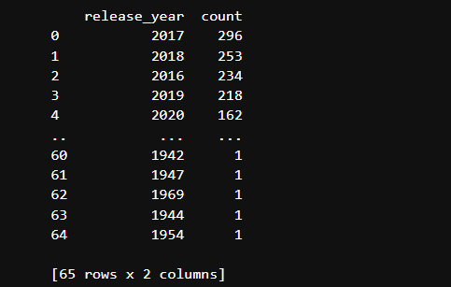
Distribution of Titles by Release Year in the United States
The table below shows a sample output obtained after grouping the dataset by the release_year column for content in the United States. It represents the number of titles released in each year.

Explanation:
- Recent Years: The years 2016–2020 show the highest counts, indicating a large number of titles have been released more recently in the United States.
- Older Years: In contrast, earlier years such as 1942, 1947, and others have very few titles, which reflects the smaller library size in those periods.
- This output helps visualize Netflix's expansion over time, with modern years dominating the content release trends.
You can use this explanation along with your chart to discuss how content production has evolved over the years in the United States.

Step 4: Insights and Conclusions
Data Analysis of Netflix's Content and Trends
Introduction
This project looks at Netflix's movies and TV shows to understand what kind of content is most common and popular.
Simple data analysis methods are used to find patterns in the content, like what types of shows are added most and from which countries they come.

Dataset Overview
The dataset has information about different shows on Netflix, including:
Title: Name of the movie or show
Type: Movie or TV Show
Director & Cast: Main people involved
Country: Country where it was made
Date Added: When it was added to Netflix
Release Year: Year it was made
Rating: Age group rating (PG, R, etc.)
Duration: Length of movie or number of seasons
Genre: Type or category of content
Description: Short summary

Data Cleaning and Preparation
Before starting, the data was cleaned by:
- Removing missing or repeated entries
- Fixing data formats (like date and duration columns)
This helped make the analysis clear and accurate.

Main Findings
Types of Content: Netflix has more movies than TV shows.
Trends Over the Years: More content has been added in recent years, showing Netflix is growing its collection.
Top Countries: Most shows are from the USA, followed by India and the UK.
Popular Genres: Drama and Comedy are the most common types.
Ratings: Most content is rated TV-MA, TV-14, or PG-13, suitable for teens and adults.

Visual Charts Used
Several visualizations were used to understand the data better:
Bar charts to show types of content
Line graphs to show trends by year
Pie charts to show content by country

Conclusion
This analysis shows what kind of content Netflix has and how it has changed over time.
It also shows how Netflix is expanding its content library to reach more global audiences.

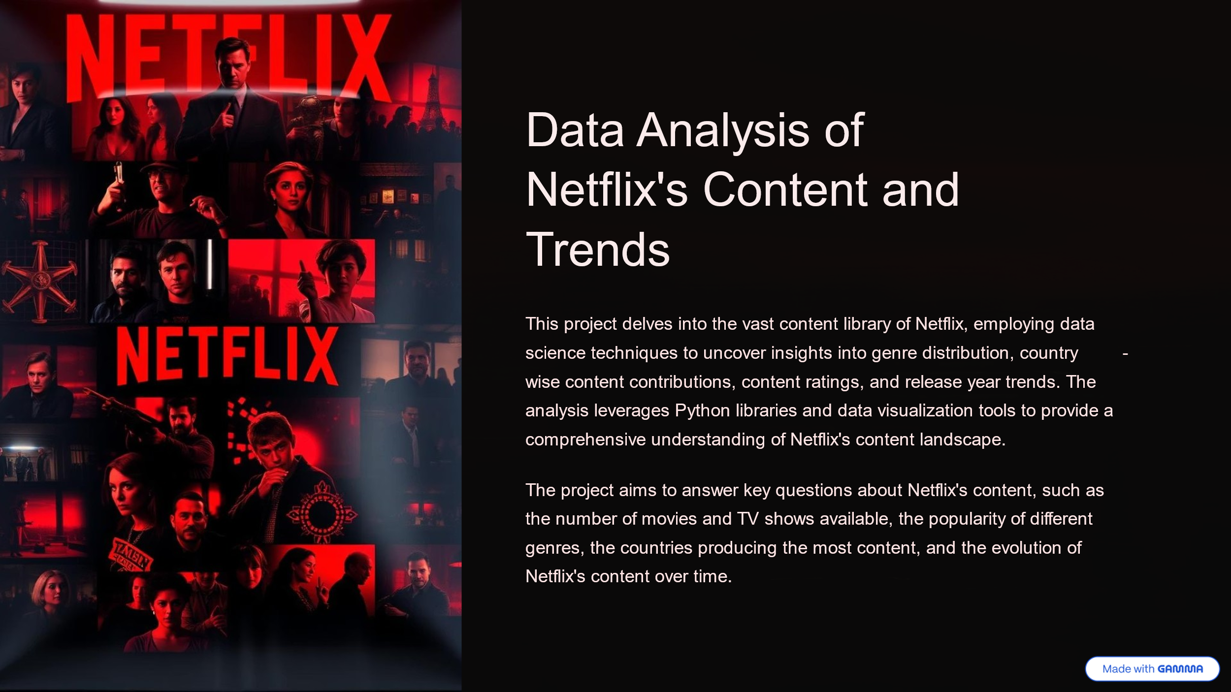

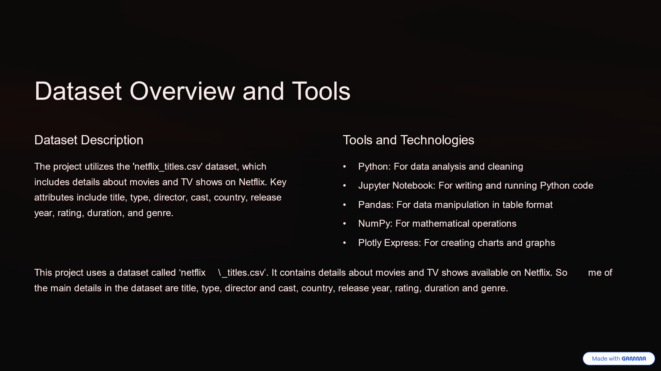
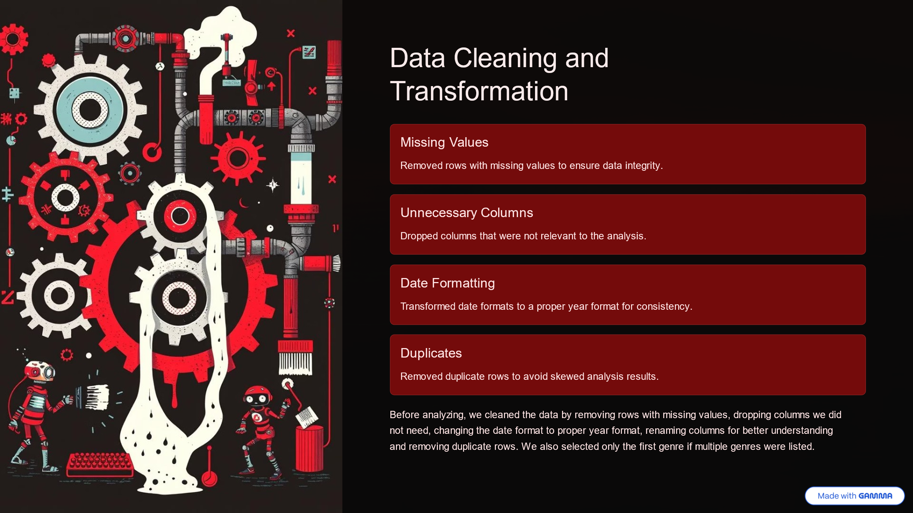
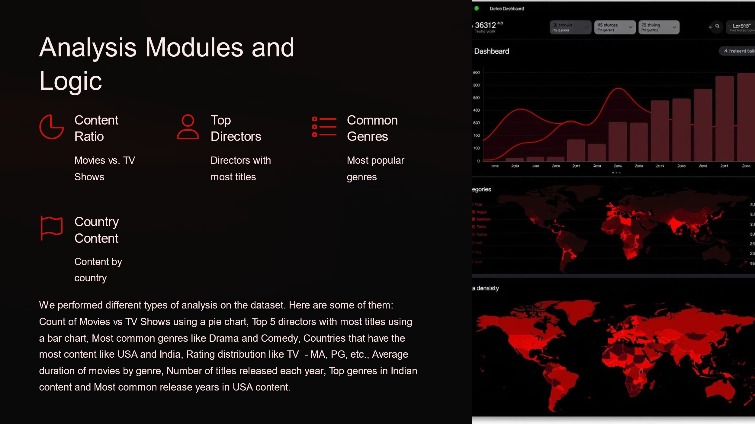
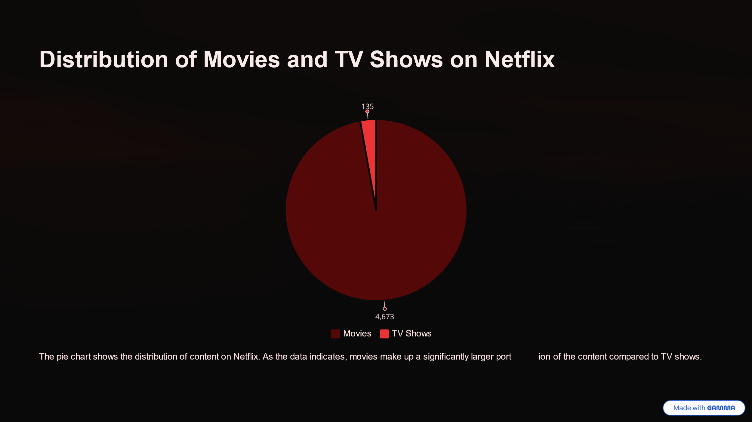
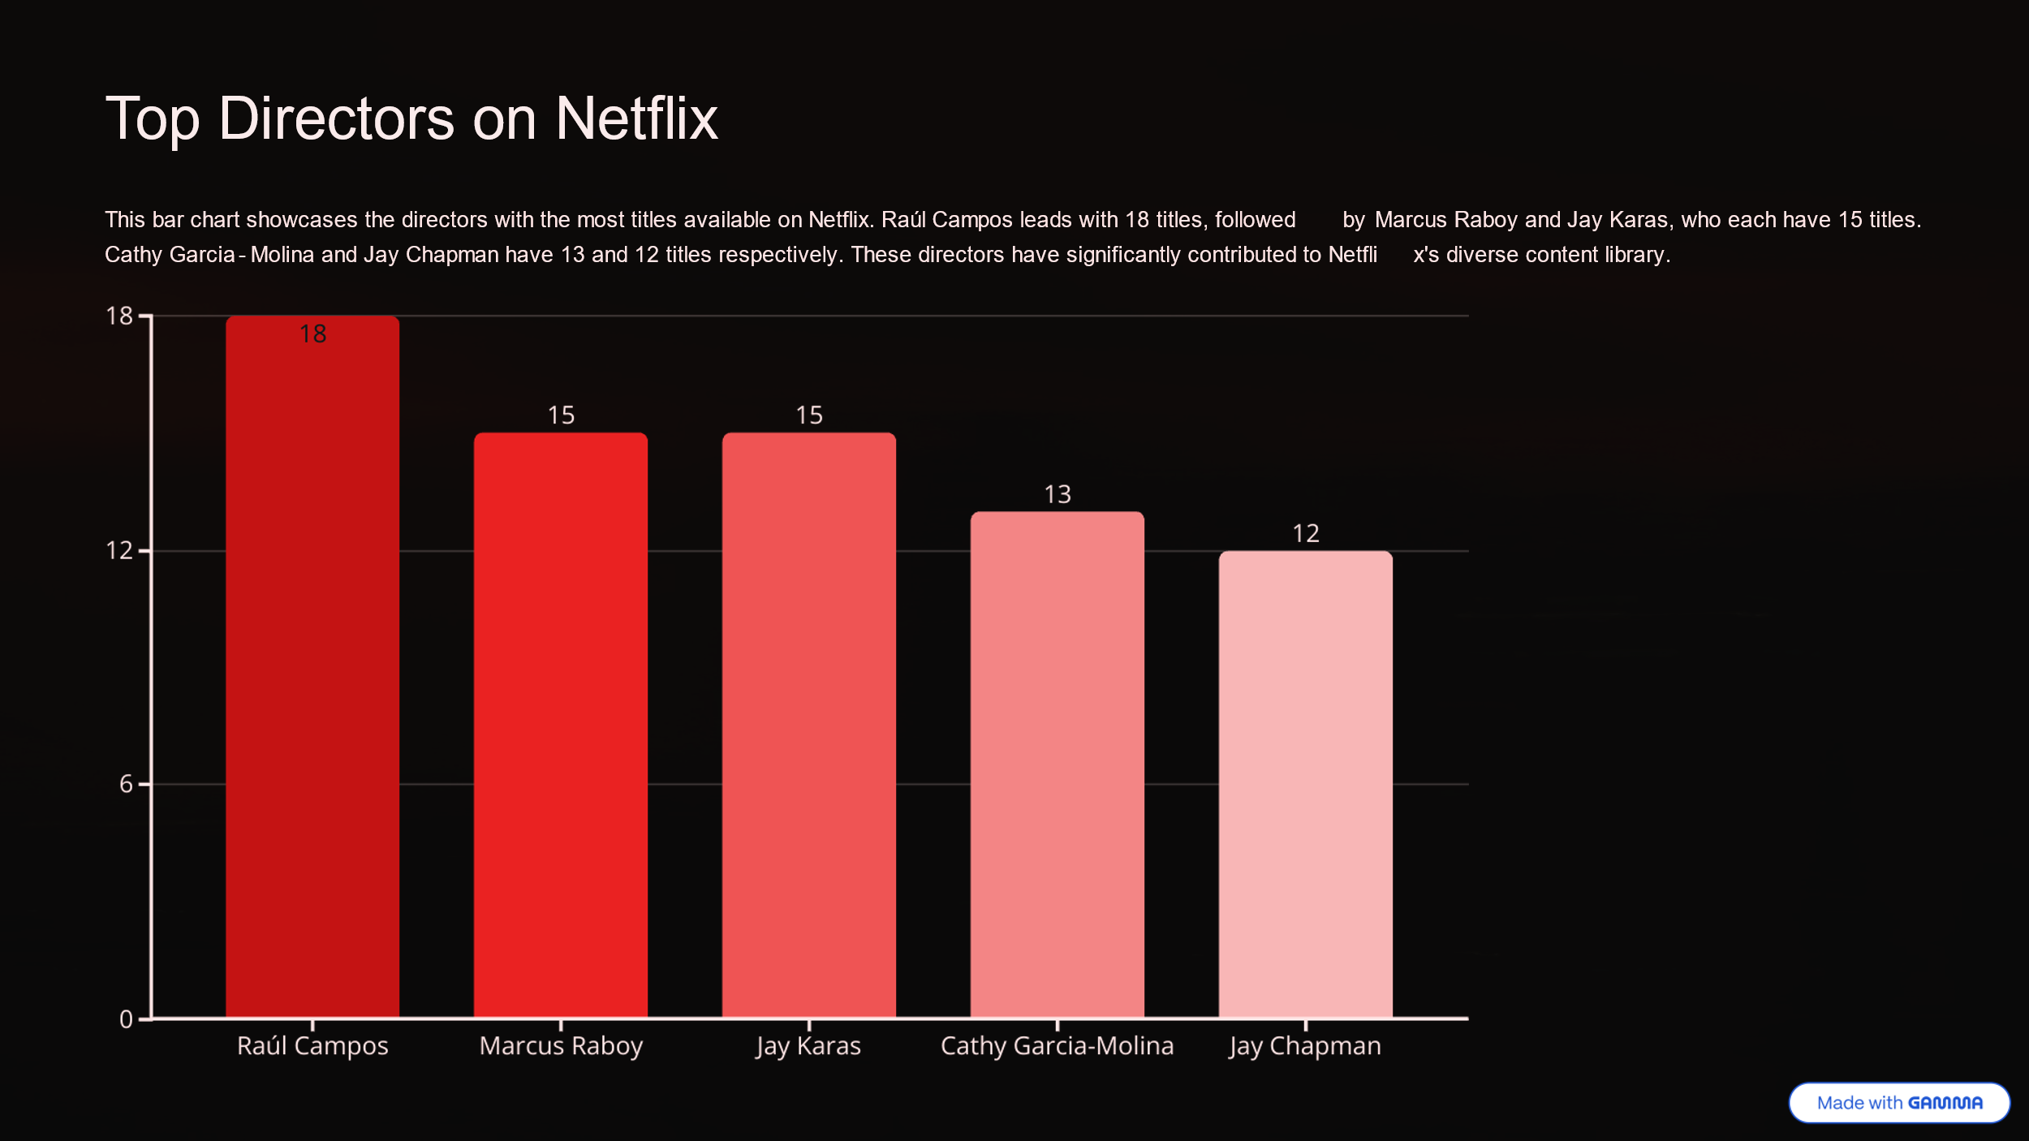
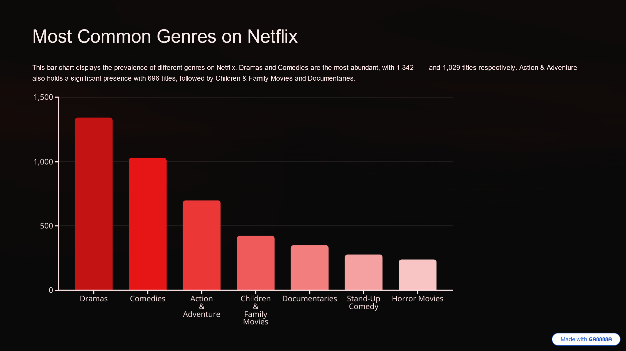
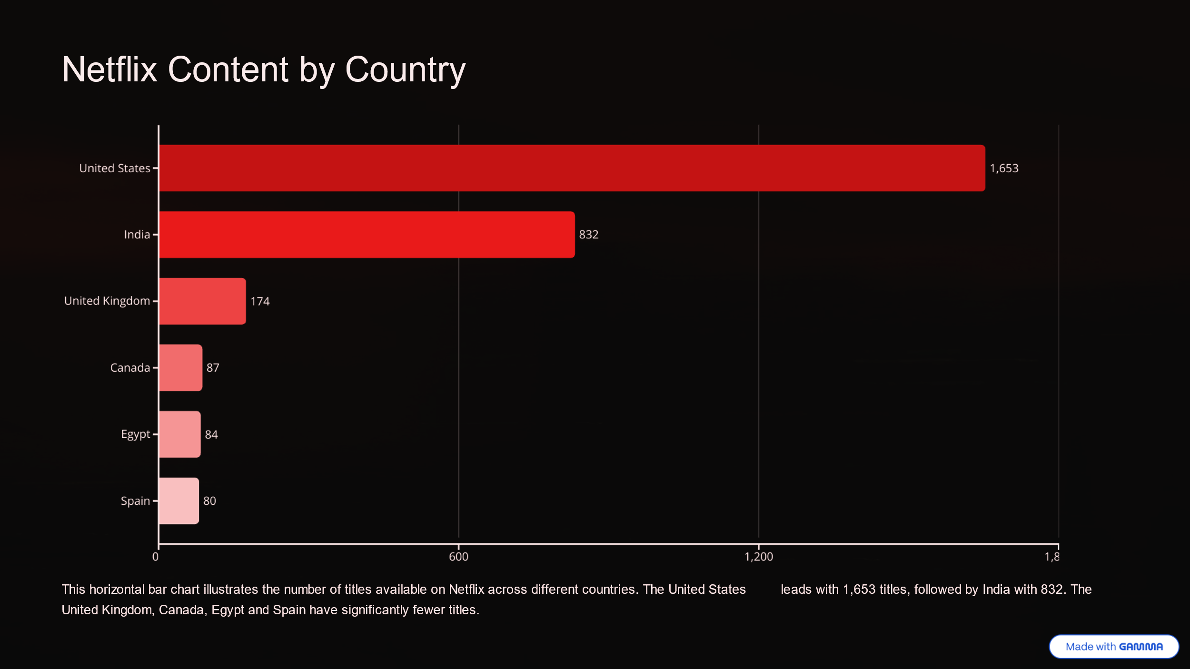
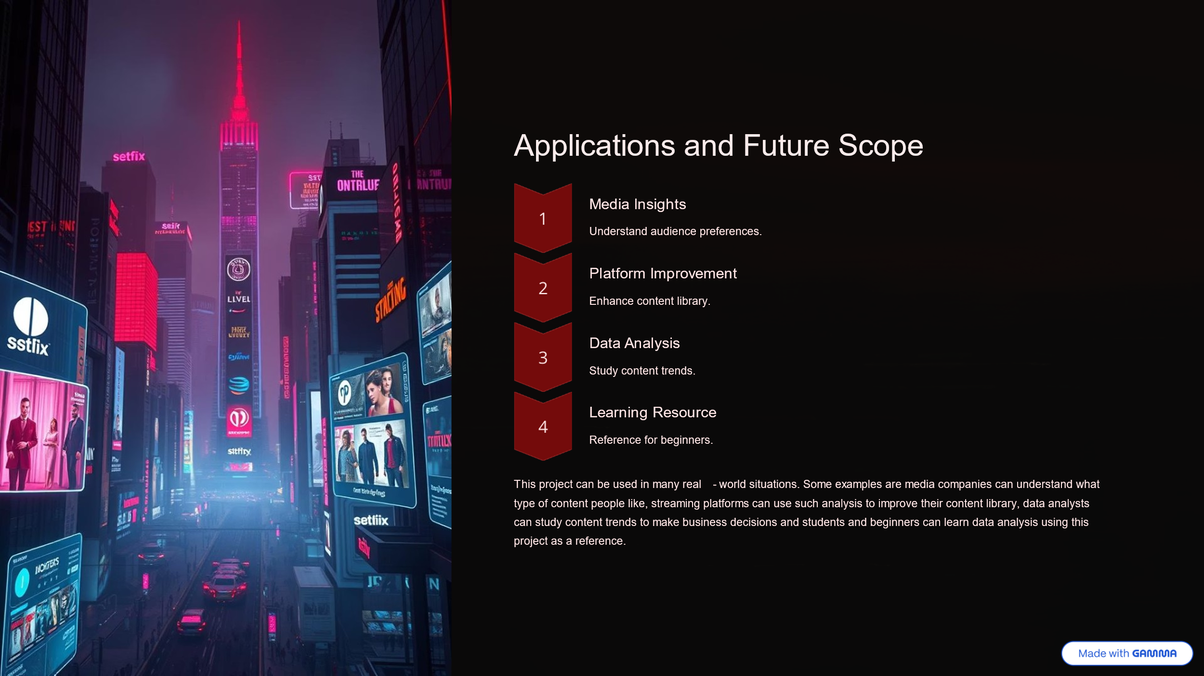
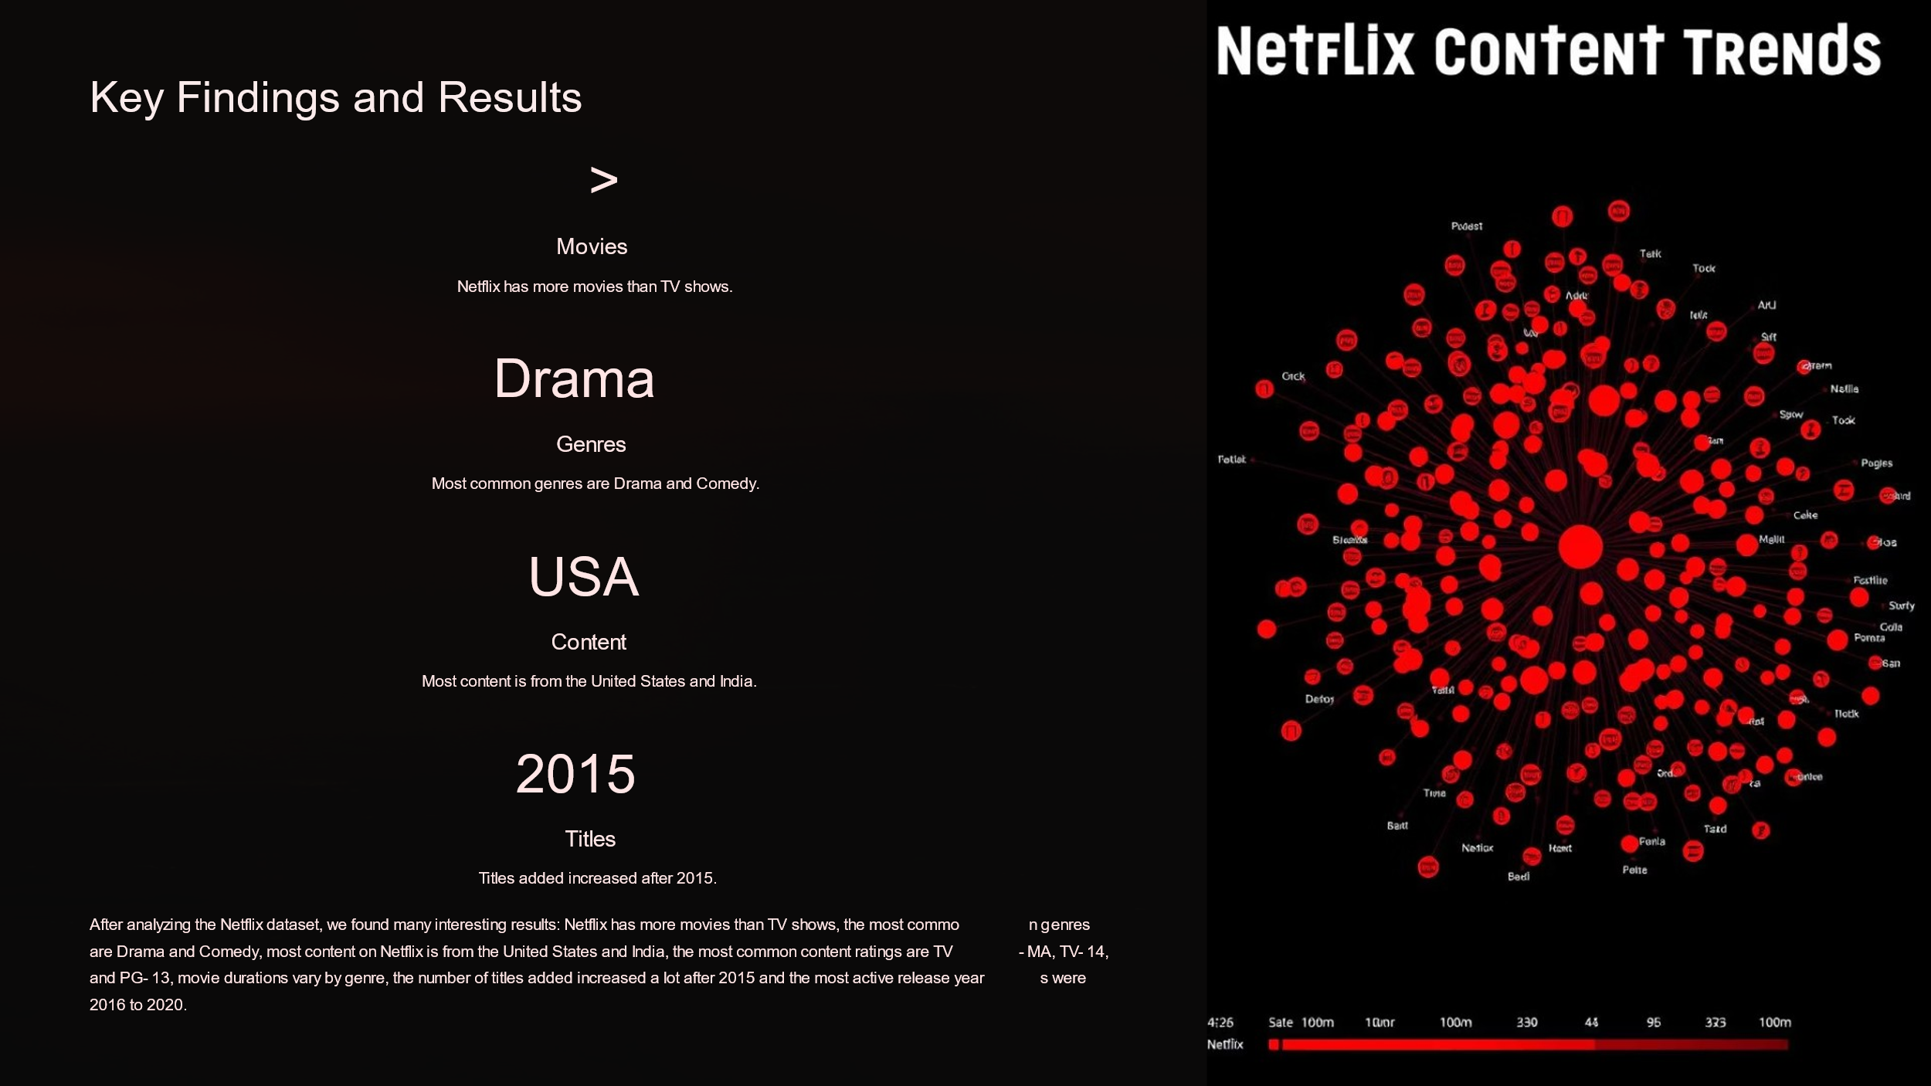
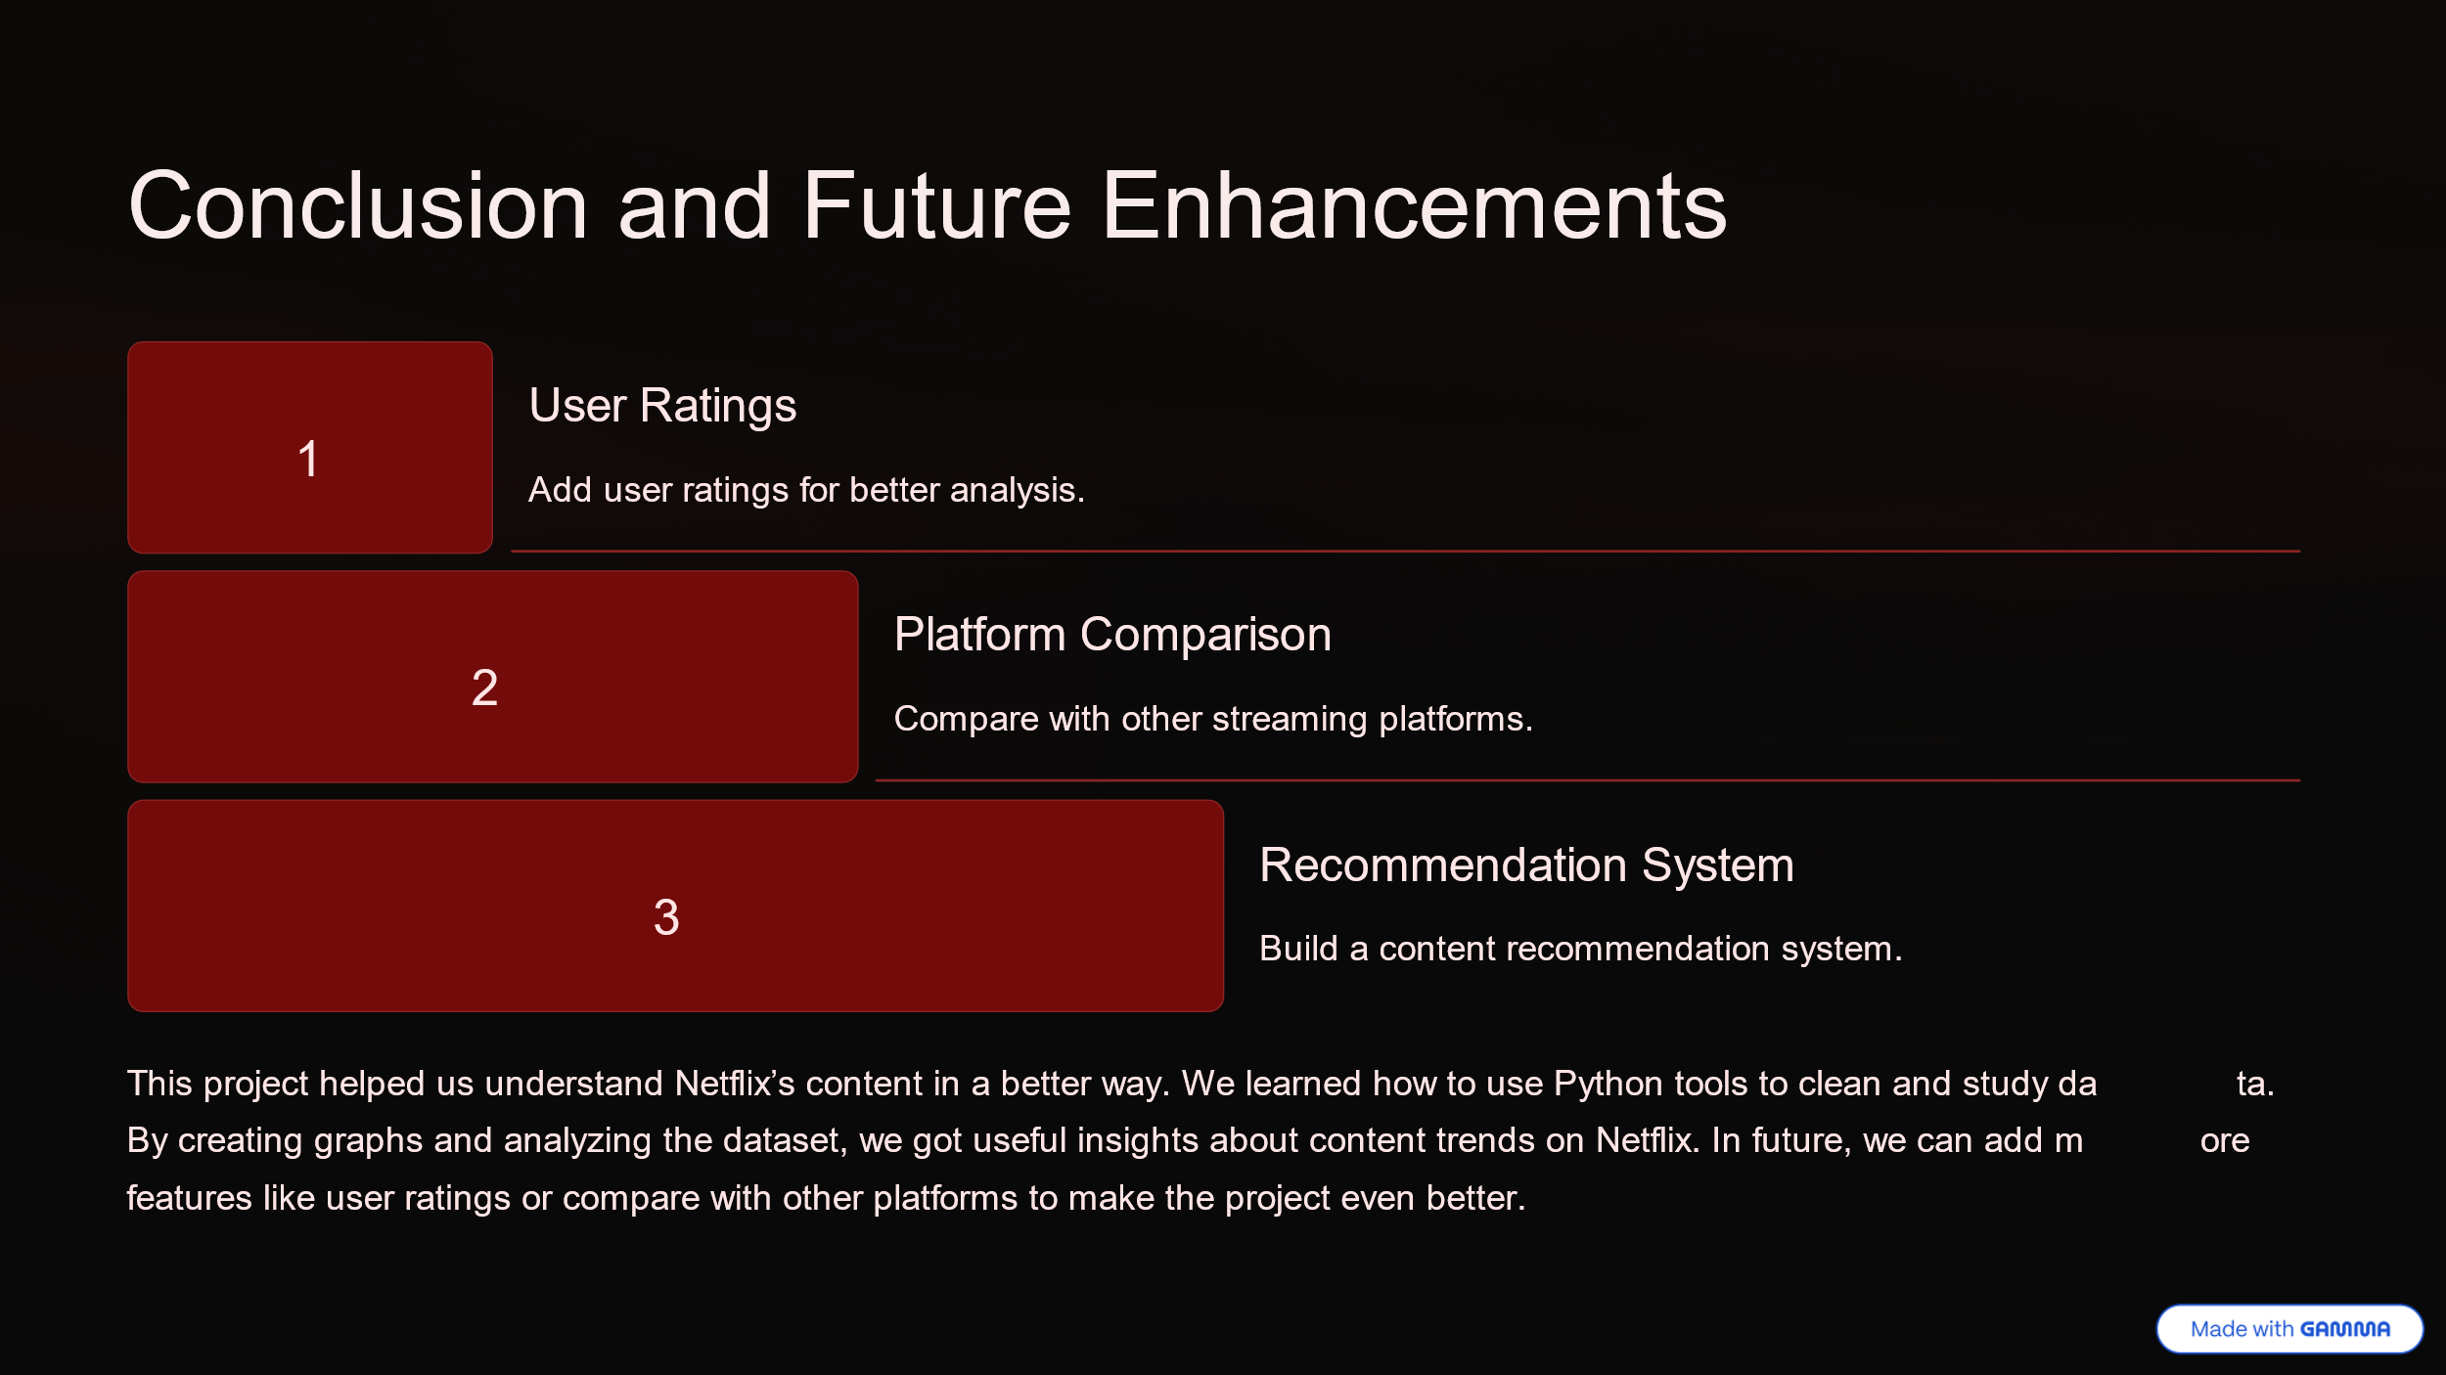

CHAPTER 7 - REFERENCES
1. Netflix Dataset: https://www.kaggle.com/datasets/shivamb/netflix-shows
2. Python Programming Language - https://www.python.org/
3. Pandas Library - https://pandas.pydata.org/
4. NumPy Library - https://numpy.org/
5. Plotly Express - https://plotly.com/python/plotly-express/
6. Jupyter Notebook - https://jupyter.org/

